Criminals will be criminals

# Introduction

Criminals will be criminals! Have you ever thought about this? No matter how you legally make something, criminals will still find a way to get it. Marijuana has been illegal for years and people have still found ways to get a hold of it and smoke it.

Now let's talk about guns. If someone were to break into your house armed with let's say a 9 mil, what would you do? You're going to want to protect yourself, right? Well, how can you do that when you're against having guns in your house? The criminal isn't going to say oh I guess this is a gun-free zone I better go get a knife instead. No, life doesn't work that way. The armed person is going to be “yes”. This is just like shooting ducks in a barrel they can't defend themselves in any way.

# Body

There was a study conducted at Harvard University. They have found that countries with more guns have less crime than those that have fewer guns. Here are some interesting facts probably not very many of you know.

The United States is number one in the world in gun ownership and yet is only 28 in the world in gun murders per 100,000 people.

Over the past 20 years gun sales have absolutely exploded but homicides with firearms are down 39% and other crimes with firearms are down 69%.

Overall guns in the United States are used 80 times more often to prevent crime than they are to take lives.

A study done by the Justice Department concluded that the assault weapons ban in 1994 did nothing to reduce crime or shootings. Like I said before criminals will be criminals.

If you notice you can do your research and you'll find out that the media only portrays and shows the bad things that happen with guns. They never show the good side. For example, in Houston just on April 13th, it concealed carrier shot and killed an armed robber who is holding an employee at gunpoint.

Guns aren't the only things that can kill people. A wrestling coach, father of five, and a husband was stabbed to death simply because he was fishing and a group of rowdy min was asked to calm down and one came over and stabbed him. If he would have had a gun he could have easily defended himself.

Let's talk about the Sandy Hook elementary school shooting. Have you ever thought that if we allow teachers and administrators to carry guns that maybe just maybe people would be more afraid to come into our schools and shoot?

If we posted signs saying beware we're armed, the school shootings would stop and even if the school shootings didn’t completely stop we could end them much quicker.

I mean, is it our duty to protect our children at these schools anyways Because of incidences like this Dan Cannon chooses to open carry so he can defend himself.

There are many other stories just like those that can prove that guns can help you. I know I will always have guns just so I can protect myself.

Let's think about the third world countries they're all socialistic countries. They have no freedoms or Second Amendment rights so they have no guns and they have no ways to defend themselves. Therefore, terrorism runs rampant in these countries and guess who they call to come defend them and when we don't send our troops they want to assist in the weaponry. If we can't defend ourselves we will become like this and end up as a third world country.

This brings us full circle. Do you remember the beginning of our country when the militias were formed to fight for the Second Amendment and the freedom of our country? We were fighting solely for the Second Amendment but for the freedom of our country and we couldn't have fought for the freedom of our country without bearing arms.

Can you just imagine what would have happened if the British would have gotten a foothold before the malicious? We would have been a socialistic country without arms under the dictatorship of a king or a queen.

Let's go the other way with it. How many of you like to eat? I know I do well just let you know not all food comes from the grocery store. Many people hunt for their meat. Some people hunt because they cannot afford to shop for meat. Buying a tag to hunt and hopefully get wild game is much cheaper than buying meat at the store. Well, game will last you nearly in a year.

According to Fox News, American hunters are the world's largest army. There were over 600,000 hunters just in the state of Wisconsin, 750,000 in the state of Pennsylvania, and 700,000 in Michigan. Wisconsin alone is the 8th largest army in the world. These men and women deployed to go hunt and not a single person was killed.

# Conclusion

People need guns to eat and defend themselves. Not to mention we need guns to defend our one nation under God.

With this kind of homegrown firepower, America will always be safe from foreign invasion.

You may not like gun that is your right. You may not believe in God that is your choice, but the first thing you're going to do if someone breaks into your house is call someone with a gun and pray they get there in time. This is some food for thought for the next time we consider gun control in America. We live in the greatest country in the world and the reason is because we bear arms.

Thank you!

[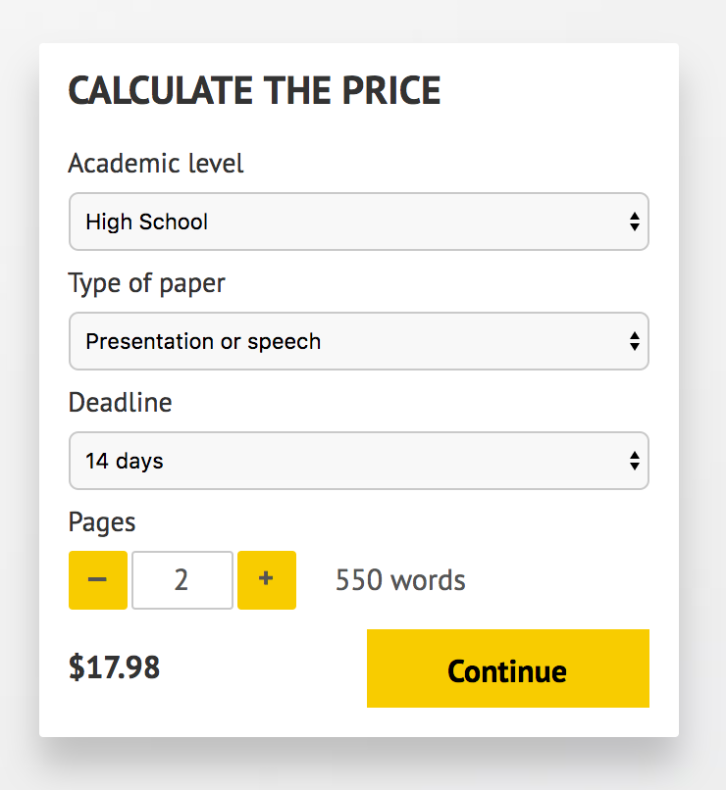](http://www.myspeechclass.com/go/custom-speech)

**IMPORTANT – PLEASE READ**

Don't use this speech as is! This document is available for anyone to download, and it has been used by *thousands* of people.

If you need help with writing a unique speech, please go to <http://www.myspeechclass.com/go/custom-speech> - you can order unique speech for as low as $17.98.