does banning firearms help prevent homicides?

# Introduction

It was late on the evening of Thursday July 19th 2012 many people filed into a movie theater in Aurora Colorado to see the midnight showings of The Dark Knight Rises. Everyone was excited to see the movie. There was no fear in anyone's mind but that changed in an incident.

In one of the theater rooms, shortly after the movie began, someone entered and began shooting. This shocked everyone in the theater because it is known that firearms are not permitted there but apparently that didn't stop him.

So, does banning firearms really help prevent homicides it's a good thought but it's also more of a wishful thought.

I believe, in a done research, that if firearms are permitted the crime rate is actually lowered a significant amount than when they are banned. Clearly, no one expected a gunman to enter to this Aurora Theater. Why? Because firearms aren't permitted and when they are permitted everyone assumes that everyone else will adhere to that rule.

# Body

I am sure that's what the people thought in 1991 at Lucas restaurant and killing in Texas where according to the online Houston Chronicle 24 people were shot and killed.

The people at Columbine High School in 1999 and at Virginia Tech in 2007, we were probably thinking the same thing. I'm safe here, but obviously these rules of not allowing firearms don't always help. They don't help because shooters make a very good assumption that everyone else will be obeying the rules leaving them to be the only ones with a weapon and giving no-one else a chance to fight back and be protected.

Despite the horrible outcomes of these types of events, some good things can arise. They often cause many people to take action and being prepared to defend themselves.

According to the Denver Post gun sales jumped 41% between last Friday morning and Tuesday morning that's in just four days. Firearm instructors are also saying that more people now wanting training for a permit to carry and from the town of the incident on Friday morning until Sunday over 2,800 people had background checks approved for them to buy a firearm. This was a 43% increase from the weekend previous and a 39% increase from the first weekend in July.

Similar increases in firearm security happened after the Virginia Tech shooting in 2007 and two years ago in Arizona, after the Tucson shooting.

Although some people feel that guns can help others think differently some believe that more laws against firearms will help prevent shootings because it should lower the number of people obtaining firearms and carrying them in public.

Rhonda fields a state representative says that she is hoping for other responses aside from increased self-defense actions. She wants Congress to ban all assault weapons and says I don't think that to be preventive we need to provide or have more guns.

Well, that would be nice but the statistical differences of homicides committed with guns being banned versus being allowed are undeniable. An argue, I read on Gun Owners of America, gives many statistics promoting permits to carry. The article is quite lengthy covering many statistics of rape breaks, child deaths, as well as giving gun facts and pointing out Mitch. So, for the sake of time I'm going a few high points:

Guns are used around two and a half million times a year for self-defense that is 80 times more the number of times they're used to take away and 50,000 times they're used for self-defense outside of the house. Thus, they appear to save more lives than they do take.

Firearms are actually ranked number 9 and the top killers in America causing just over 28,000 deaths per year.

Our number one killer is heart disease which causes over 700,000 deaths annually. That would mean you are more than 25 times more likely to die from heart disease than you are to die from getting shot. But this doesn't always lessen the fear of it happening.

In fact, a study done by the Justice Department found that a criminal's biggest fear is getting shot while committing a crime and over 70% of the felons pole agreed that empty houses are a target for burglars because they are afraid of getting shot and over 50% of the felons polled said they are more worried about running into an armed citizen than they are a police officer. This has to make you think that allowing permits to carry would help lower the crime rate.

However just because firearms are not the nation's largest killers some areas have more problems than others. Washington DC, a place where firearms are prohibitive, is considered our murder capital and experience a 51% increase in murder rate in the 25 years after banning firearms. But despite being just across the border Arlington Virginia a place where firearms are allowed has significantly lower homicide rates.

Vermont, a state that also allows permits to carry, has been one of the top five safest states in the nation for over ten years and in Florida, a state where you are more likely to get attacked by an alligator than a weapon holder, homicides rates fell 52% over 15 years after permits were made available.

And finally, the last statistic for you; in Kennesaw Georgia, a city of around 30,000 people, it is law that every household has at least one firearm. After enforcing this law burglary rates dropped 89%.

# Conclusion

So, based on the research I've shared with you I strongly feel that gun control doesn't help as much as it harms. I know that placing bands can be a comforting thought and bands have good intentions the statistics along with plain observations make it clear to see that bands don't really do as much good as we would like to think. People wanting to kill will find a gun or another weapon, no matter what the laws are.

So why not allow other people to have a chance to defend themselves instead of having to sit there helpless and letting the killer kill. It permits to carry were allowed in more locations many killers could be stopped before they have a chance to kill everyone in the room. Just think of how many lights could have been and could be spared if people were allowed to keep the liberty to defend themselves.

[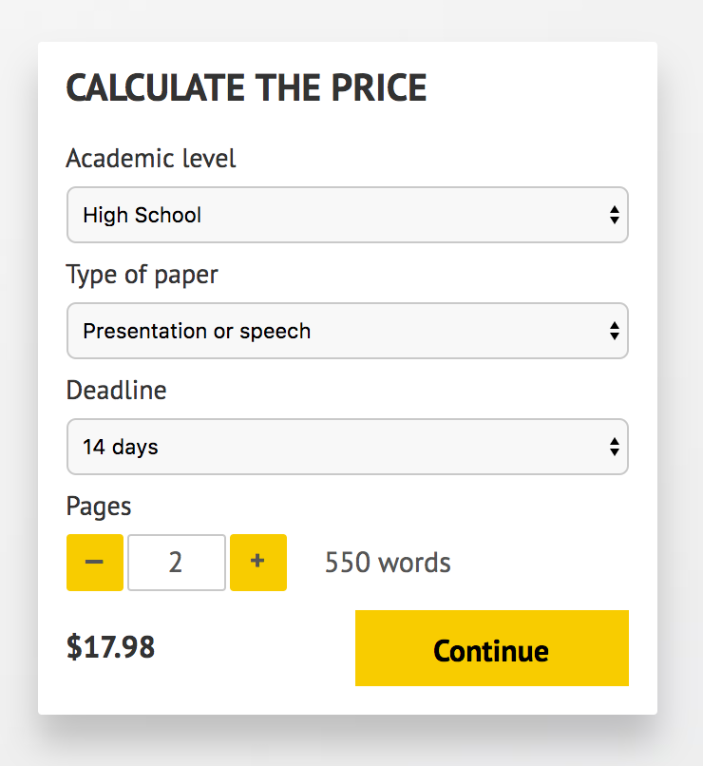](http://www.myspeechclass.com/go/custom-speech)

**IMPORTANT – PLEASE READ**

Don't use this speech as is! This document is available for anyone to download, and it has been used by *thousands* of people.

If you need help with writing a unique speech, please go to <http://www.myspeechclass.com/go/custom-speech> - you can order unique speech for as low as $17.98.