Gun violence and control

# Introduction

Today I'm going to share some information that might be mind boggling on gun violence and control. Specifically, I will discuss our current right issues that we have with gun violence and possible solutions.

We have a serious issue on our hands.

Every day 32 Americans are killed by a gun. Your neighbor could be that child that walks into a school and shoots your child because we didn't watch our concern because as a whole we did nothing to change the problem. So, what exactly is gun control and how can it help us.

Today I will discuss some of the shocking statistics, sad stories, and a beautiful plan.

# Body

To start off, I will discuss the current problem we have. In recent news, a school and Ohio suffer the loss of three students after a young man shot them with his grandfather's gun. He accessed this gun because it was not locked up in a safe. No law was broken by the government with let's face the facts this is not gun control.

That is setting our children up for disaster you ever expect that your child will be army crawling that their way to safety as bullets fly past their head in school. In Akron, this past summer an eleven-year-old girl was shot and killed by straight bullet.

Controlling the safety regulations for gun owners almost seems like a necessity. Gun control is the government placing walls or codes that gun owners have to abide by.

Colin Goddard who works for the Brady Campaign to prevent gun violence said this while being interviewed by MSDN about the Chardon High School shooting:

Eight children die every day from gunfire.

You have 32 Americans that die every day, that is the Virginia Tech shootings that happens every day and we do nothing about it. It is beyond time that we do something about it.

Colin Goddard was shot four times in the Virginia Tech shooting. He is a surviving victim and is now helping the Brady Campaign and their fight for gun control.

In his interview, he stresses that the dangerous easy accessibility to guns, the University of Arizona is trying to pass a bill that allows students to carry firearms on campus.

Here are some shocking statistics:

The FBI buys primary in the United States estimates that 68% of the 16,929 murders in 2007 were committed with firearms.

According to the 1997 survey of state prison inmates among those possessing a gun the source of the gun was from a family friend street by or illegal source. That represents 80% of all those inmates that use the gun.

Based on the survey data from a 2000 study published in the Journal of quantitative criminology, US civilians use guns to defend themselves and others from crime at least 989,883 times per year.

Homicides of teens and young adults, who are most likely to be committed with a gun than any other person of any other ages, the percentage of homicide victims killed with a gun increased with age of the victim until 17 where it peaked at 79% and then declined thereafter.

Those are some heart-wrenching statistics and stories but if you put thought to them but there are ideas in the works by various organizations.

The Brady Campaign is well known for its push on gun control. On the Brady campaign's website, they rate a state-by-state to see how well our gun laws are:

California got 81 out of 100 with the highest score in the country.

Ohio had 7 out of 100. It seems as though almost any in Ohio can buy a gun.

The more you understand about gun violence the more you might understand the fight for gun control.

According to the report card for Ohio the points awarded to the heart of the country are 43 points for reporting lost or stolen guns by the owner and 4 points for no guns in the workplace or college campuses. Those are our only current restrictions for gun owners.

# Conclusion

Now you know enough about gun control and what it benefits out of the country and our future generations. The statistics, the reality, the idea is to help reduce the number of gun-related deaths.

Hopefully you understand that gun control is not stripping you of your amended right to bear arms but protecting you from going victim to someone that easily access to gun when they should have been able to.

[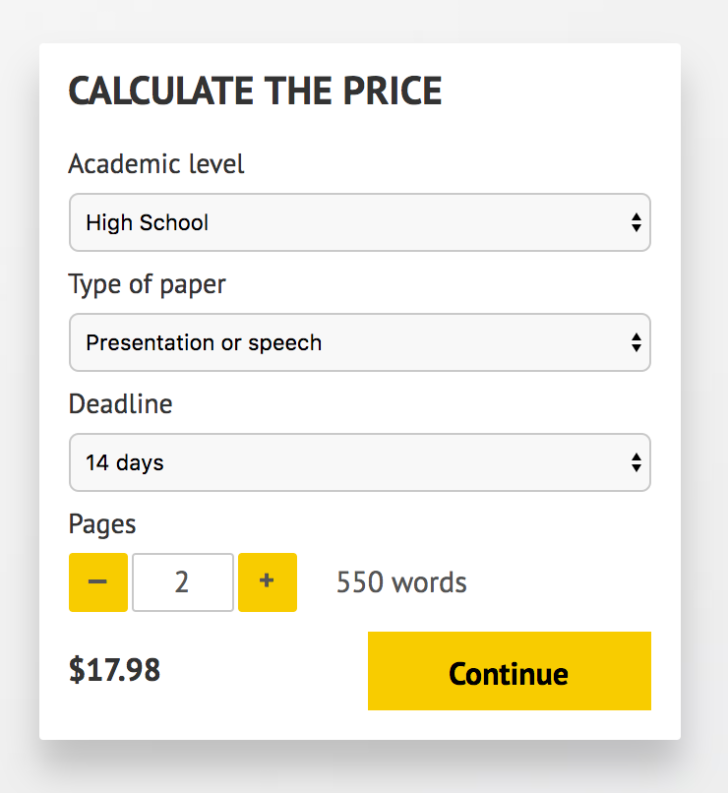](http://www.myspeechclass.com/go/custom-speech)

**IMPORTANT – PLEASE READ**

Don't use this speech as is! This document is available for anyone to download, and it has been used by *thousands* of people.

If you need help with writing a unique speech, please go to <http://www.myspeechclass.com/go/custom-speech> - you can order unique speech for as low as $17.98.