GUNS DON’T KILL PEOPLE

# Introduction

“Guns don't kill people, people kill people” that is the quote from the National Rifle Association.

So, what is the real problem with guns in the United States? You know many persons through history has used guns for good and bad things but recently a surprising number of people think that banning guns is a good idea. They think that it will rid America of gun violence but this isn't very good reasoning. The reasoning behind banning guns basically is this; if guns can't be purchased or sold and nobody can legally possess a firearm a technical term for a gun that “gun violence” will happen, right? Wrong, bad people will always find ways to get a weapon to their bad deeds.

# Body

Banning guns just because they have an ability to kill people is like banning this spoon because it has ability to make somebody fat, doesn't make much sense, does it? But it all depends on whose hands the gun or the spoon is in as to whether it'll be good or bad.

I do believe that a firm gun control needs to be put in place a better form, better background checks, age limits. For a private sale of a weapon, that's not through a licensed federal firearms dealer; Age checks, proper instruction, and handling a weapon.

An example of this is within the last ten years a law was put in place that nobody can own a handgun and any gun with a barrel under 18 inches before they passed a certified handgun safety course in the state of Michigan.

If weapons are banned then it puts up staying the citizens in harm's way and they can no longer protect themselves from people with bad intentions. An example of this is recently a man in its mid-60s was being held up by a robbery in a Wal-Mart parking lot and he had to fire two shots but the criminal wasn't hurt. Had the man not been armed licensed by the state of Michigan to carry a concealed weapon it could have been much worse for him not be here today.

Also, it's a constitutional right set out in the Second Amendment which states and I start quote “A well-regulated militia being necessary to the security of a free State the right of the people to keep and bear Arms shall not be infringed”.

So, if guns are banned then it will infringe on the Second Amendment right and the basis our country was founded on.

To show the guns aren't the problem and people really are; in 2014, there was 32675 vehicle related deaths car accidents that there were fatalities in and 1405 fatal gun related incidents even though there are 20 million more guns than cars in the United States.

Also, far more people are injured fatally by everything from spoons to knives even hands. But it's having common sense and knowing weapons are necessary for survival in many northern parts of the continent along with the fact that it's a heritage in the country to grow up and hunt and live off the land.

Personally, I've grown up with guns my whole life. I've hunted with them and shot them numerous many times more than I can even remember but I've never seen anybody get injured, hurt or killed. I've never been responsible for anybody hurt because it all comes down to how you handle that weapon.

But as Americans we shouldn't be afraid of guns but people need to rethink the respect that they give those guns. So, also the type of weapons I need to be regulated like AR-15 style weapon with a 30-round magazine it might not be necessary for home defense or hunting but they certainly have their place. But limiting the magazine to only holding ten rounds definitely be a good step in the right direction but that's a speech for another day.

# Conclusion

So, overall banning guns is a bad idea, it leaves civilians helpless against threats. It fringes our constitutional rights and it takes the heritage of the great outdoors away.

The only answer I believe in solving gun violence is being smarter with guns and not harder on the people. What I mean by this is looking at instances where people have done bad things with guns and then look at instances that for years people have not done bad things with guns. They had common sense, they've hunted and lived with guns for years and nothing bad has happened. But that's another speech for another day like I said.

Thank you for your time!

[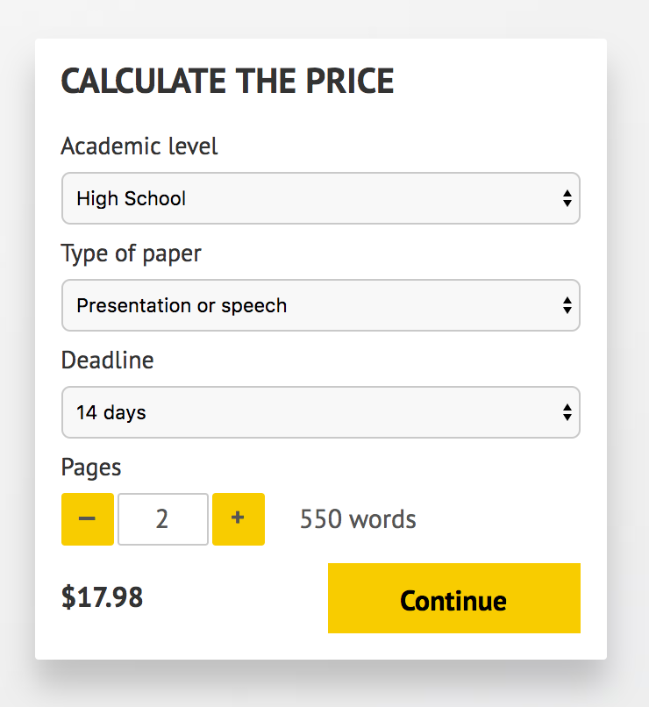](http://www.myspeechclass.com/go/custom-speech)

**IMPORTANT – PLEASE READ**

Don't use this speech as is! This document is available for anyone to download, and it has been used by *thousands* of people.

If you need help with writing a unique speech, please go to <http://www.myspeechclass.com/go/custom-speech> - you can order unique speech for as low as $17.98.