SPEECH AGAINST stricter gun CONTROL

# Introduction

I am 15 years old and I have been shooting for almost 8 years. I've also been a part of the Maryland rifle Club at Maryland State rifle team since I was 11. We shoot semi-automatic AR-15s and my personal rifle is a Bushmaster. Because of this I've become eligible for various shooting scholarships around the country to a wide array of even the most prestigious colleges that have shooting teams. Achieving stricter gun control laws would obliterate any opportunity I could have had to attend a decent college on a shooting scholarship. Ever since I first learned how to shoot the issue with gun violence around the nation became clear “guns are not the problem people are”.

# Body

Purging our society of violence and murder cannot be done through gun control legislation. By signing this legislation, you are not signing away gun violence but instead liberating American citizens of our constitutional rights.

You are not eliminating guns from society but eliminating our ability to protect our lives liberty and pursuit of happiness.

Chicago, Illinois has some of the strictest gun control laws in America enacted for the past few years and it is currently more than twice as likely for you to be killed in Chicago is in the Afghani war.

For the past 11 years and 4 months in the Afghani war 2,166 people have been killed. Now in only 8 years in Chicago 4,265 people have been killed in 3,371 of them were from being shot. Is that really something we want to model our state laws after?

Now even though those 3,371 only 37 were killed with a rifle which is barely 1%, 98% were killed with a handgun so creating a gun control legislation that targets assault rifles has statistically proven to only read out less than 1% of the problem if you're lucky.

I would also like to point out that none of the guns used in the Chicago shootings were registered or licensed to the people who use them thus even further proving that simply restricting guns will not stop criminals from using them nor will restricting guns stop criminals from harming others in general.

On December 14th of 2012 the same day as the Sandy Hook shooting in central China a man stabbed 22 children and one adult.

Guns are not needed for mass murder and robbing American citizens of our rights to own them won't solve anything, you must also consider the fact that the majority of gun violence occurs in low income neighborhoods raising the overall also owning a gun through higher licensing and registration fees denies the ability of low-income individuals to protect themselves against the crime focus in the areas they live in.

Passing this legislation would be discriminating against these lower-income individuals who are actually at a higher risk of being victimized and crimes. To abolish or severely limit the right of the Maryland residents as a whole to bear arms which is the intent of the proposed legislation is to essentially defeat the purpose of our own US Constitution.

# Conclusion

The entire foundation of the United States was formed on the principle that the government “our government” is a government of the people, for the people, by the people and taking away the people's right to bear arms is taking away the people's power in the government.

The Second Amendment which grants the citizens the right to secure their natural rights is a backbone of our democratic society I hope you all consider these points as you go to vote on this or any other gun control bills.

[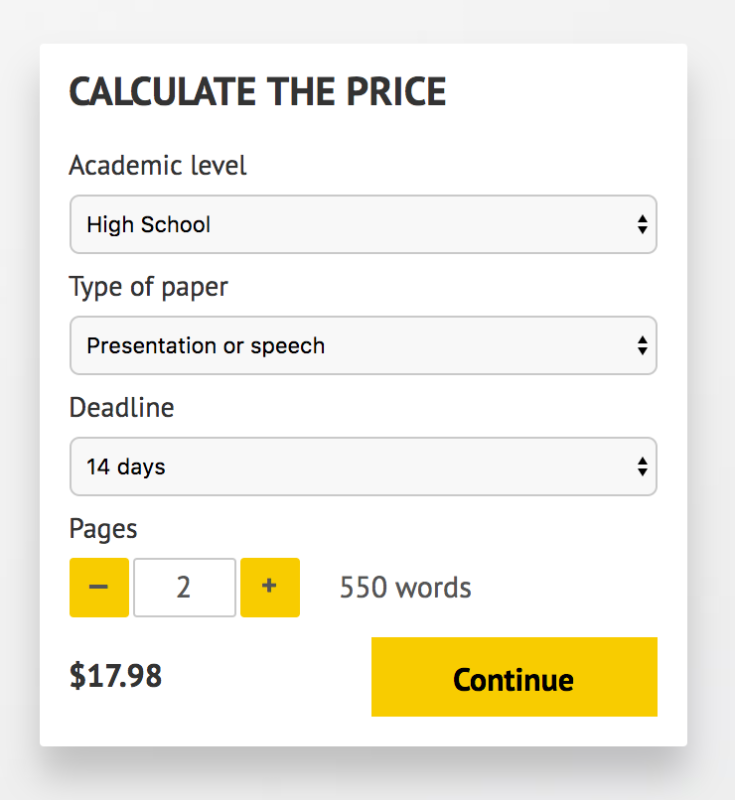](http://www.myspeechclass.com/go/custom-speech)

**IMPORTANT – PLEASE READ**

Don't use this speech as is! This document is available for anyone to download, and it has been used by *thousands* of people.

If you need help with writing a unique speech, please go to <http://www.myspeechclass.com/go/custom-speech> - you can order unique speech for as low as $17.98.