the controversy over Gun Control

# Introduction

With the shooting of the two sign Arizona fresh in our minds the controversy over the gun control is a heated debate in Washington DC. Currently the president of United States pushing for more gun control and we as Americans are sitting back and allowing this to happen.

Good afternoon! My name is John Doe and today I will be talking to you about the controversy over gun control and what we need to do to be able to fix this problem in our country.

In today’s society, we as Americans make an assumption that our government is going to do everything in our best interest. Now in a perfect word that would be the case but unfortunately that is not the word we live in. Today we live in a world that is consumed by the media and the media that we use on day-to-day basis and we have become ignorant to the fact of our Second Amendment right. According to the NRA (The National Rifle association), the majority of Americans do not realize that the Second Amendment right is right to bear arms. We must learn what our rights are to be able to move on into this country and go forward with what our forefathers has set forth for us. The right to be able to protect ourselves and the right for us to be ruling our own government.

# Body

“The Land of the Free and the Home of the Brave”, ladies and gentlemen, this is the word that we lived by. But I don’t think we fully understand the significance of those words. Freedom is not free; freedom is paid in full in every single day by our local, military, and police forces, who protect you and I 24 hours a day 7 days a week.

Ladies and gentlemen, I would tell you it would be a shame for the same police officer who protects us to protecting serve. When he clocks out at the end of the day that he goes home unarmed unable to protect his own family in case of emergency. Ladies and gentlemen, this is not what our forefathers intended to do for us. Our forefather had a vision – a vision for our country.

Now I realize that in 1775 things were a lot different but the same thing applies today, protect your family at all cost, protect your government at all cost, and protect that flag that represents our great nation.

Ladies and gentlemen, I propose to you not to think emotionally but think cognitively on this decision “The right to bear arms”. It is in the best interest of our nation as a whole.

Now, I know what you are thinking: what about all the violence that happens in cities across this country every single day? Ladies and gentlemen, no one wants violence but evil works when good people do nothing. We must have the right to protect ourselves at any given moment. What our government is trying to do right now is trying to remove those rights and allowing us to become vulnerable not only in our communities but as a nation.

I am not trying to make you fearful of the fact that we may be invaded by some far off country but it is a possibility that we cannot go on thinking that it is not. Ladies and gentlemen, it is a possibility and it can happen as quickly as tomorrow. That means you must get involved. I visualize our nation becoming stronger than what is already.

Make no mistake, ladies and gentlemen! We do live in the greatest country on the face of this planet. It was given to us by all our predecessors’ death fought for our country and fought for the flag; the red, white, and blue. But I still have a vision that we become more involved in our communities, we become more involved in our government and that we, you and I, are able to make those decisions. Gun in hand whatever it may be but WE MUST NOT LOSE THAT RIGHT.

# Conclusion

In closing, I would like to leave you with a few words. Ladies and gentlemen, what we have discussed here today is very important, not only to me but to everyone in this country. Like it or not, it is a fact! It is a fact and it is our right as Americans. Ladies and gentlemen, we must not allow our government to slowly disarm the American public. We must stand together and defend our freedom and our right of the Second Amendment.

Our forefathers established this amendment for specific reasons; to protect our homes, to protect our nation. Ladies and gentlemen, this decision should not be left up to just a few people in Washington DC. This decision needs to be made by you and I, we need to become involved because if we don’t, we would have lost everything in this country was founded on.

Ladies and gentlemen, I know in my heart after hearing what I told you today that you will make the right choice.

This concludes my speech on gun control.

Thank you again!

[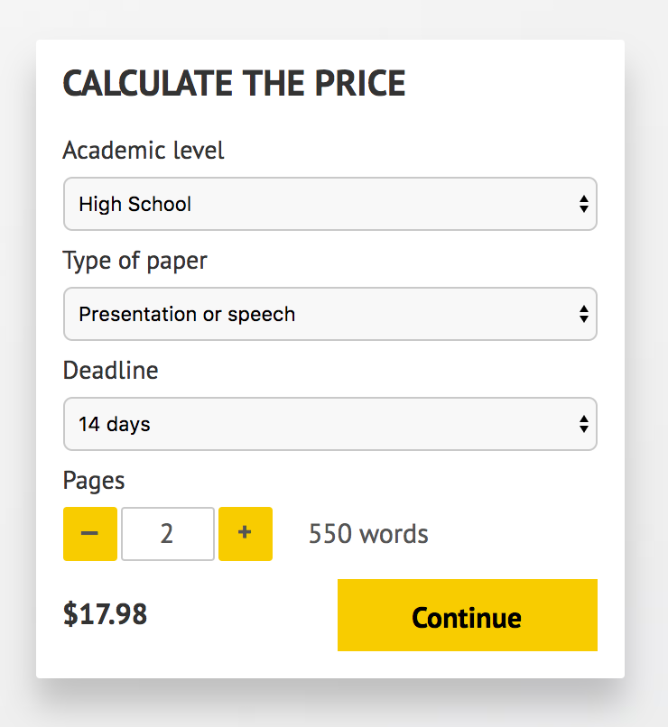](http://www.myspeechclass.com/go/custom-speech)

**IMPORTANT – PLEASE READ**

Don't use this speech as is! This document is available for anyone to download, and it has been used by *thousands* of people.

If you need help with writing a unique speech, please go to <http://www.myspeechclass.com/go/custom-speech> - you can order unique speech for as low as $17.98.