the truth about gun control

# Introduction

Imagine you in your home and it's the mid of the night and you and your family are all sleeping soundly. All of a sudden you wake up to realize that your home is being invaded. Now the story can end in one of two ways; you can either defend yourself or you can lose your personal belongings and possibly your loved ones. People argue that other weapons like knives or mace might work. But when your criminal is armed with a gun I'm not sure would be effective. You can also call the police but it takes a few minutes for the police to get there while it only takes a few seconds to be shot.

I've done extensive research and it has shown me the truth about gun control. While many people believe that “more guns - more violence”! Here are my reasons why I'm against that theory.

# Body

Outlying anything only creates a black market. When things are illegal you cannot regulate them and it turns regular people into criminals. People will find nothing find a way to get what they want whether it is legal or not. When normal law-abiding citizens aren't doing this, they are also exposed to other crimes leading them down a slippery slope.

As we should know guns aren't going anywhere aren't disappearing anytime soon. Criminals will get their hands on guns while law-abiding citizens want have access and criminals will notice. They will import guns illegally they will produce their own guns at a secret location and then they will turn around and sully sin for money free of tax drive creating even more of a desire to continue and increase the legal gun production.

On these things supporting underground industry that is merely been created by the government itself. If only criminals possess guns, who do you think is going to win in that war?

My second issue is defense on the grim day of July twentieth 2012 in Aurora Colorado there was a movie theater shooting that changed many lives. It killed 12 people of all ages the youngest three months old while the oldest 51 years. 58 others were also injured and were forced to fight for their lives that night. Reporters, politicians in other media immediately jump to strict gun control laws. This is the opposite way that I would have done.

If the public will be more able to carry guns when the killer has been so brave to shoot at an innocent crowd of people, would he have thought twice about shooting had he had the chance to receive a bullet himself. According to smartgunlaws.org only days after the incident Colorado approved background checks for people to purchase a firearm at a 43% increase from the previous week.

A story on gunssavelives.net illustrates a twelve-year-old girl from Oklahoma who refused to be a victim After hearing her home door being kicked in, she screamed for her mother. He then told her to grab the family gun and go hide. She did so and hid in the closet. For only moments later the intruder tried to open the closet door. The younger will have braced herself and her gun and shot through the door hitting the intruder. The intruder fled the scene but was later caught by police. The intruder had been found to be arrested just one year earlier for kidnapping.

Many other stories similar to this have been told from all across the country. People who have been Indian students and banks and stores and everywhere we go on our daily lives told by the young the elderly the disabled in the normally physically defenseless. On the job in convenience stores and other places but especially by those who had thought that they would never need serious protection like a gun.

Some statistics I have are from BBC which says that Switzerland gun crime rates are so low that they are not even keeping record. Some believe that this is related to their centuries of encouraged gun practice for the people. According to the New York Times the popular study shows that more strict gun regulation hermits proves that fewer guns get to criminals where regulation is not enforced. Many places have seen lower gun crime rates when the public was able to access firearms

My last reason is of course the Second Amendment. The Second Amendment says a well-regulated militia being necessary to the security of a Free State. The right of the people to keep and bear arms shall not be infringed. While some people think that the Second Amendment only says that the military and other government officials are the only ones that have right pick up to firearm. It clearly states that it is the right of the people.

If guns are outlawed how will you stay free? If guns are outlawed how we be able to defend ourselves in the government and how we come to an extreme situation without all right we've become vulnerable. We as American citizens need to exercise the right to protect ourselves and protect our loved ones from criminals and from the government. Our forefathers obviously created the Second Amendment for a reason and that is for protection.

# Conclusion

My final note is it I believe that the solution to our problems is just to crack down on the current regulations that we have today. What we need to do is make them tighter with better background checks, background checks that you don't receive from your gun store that you receive from government officials that are more in-depth and more secure.

The second thing would be to educate more people. If more people know how to use guns there will be less safety issues because they will know how to keep themselves safe and others safe. If more people are educated then everyone is safer. We cannot sit and allow the government to take away our freedom. Means we cannot be happy and we need to be more involved. You can do this by voting and making sure that the government knows what we have to say because we should be ruling our government the government should not be ruling us. We must not lose our right because if that were to happen what else could they so easily take away.

Isn’t it better to be safe than to be sorry?

[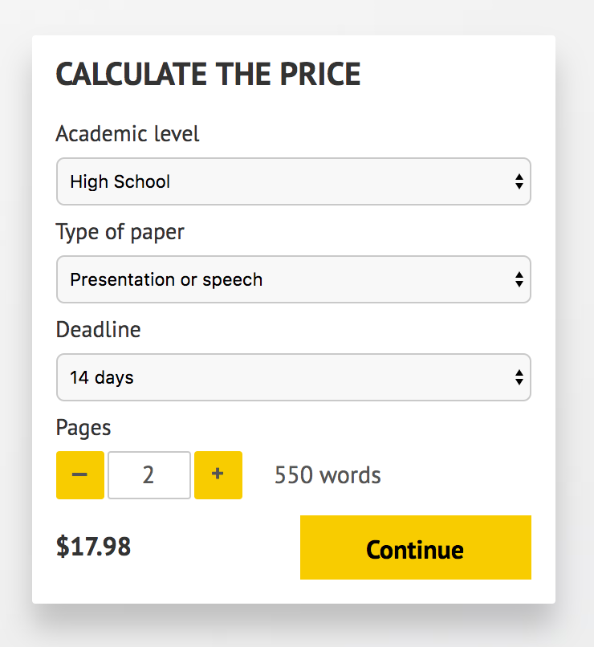](http://www.myspeechclass.com/go/custom-speech)

**IMPORTANT – PLEASE READ**

Don't use this speech as is! This document is available for anyone to download, and it has been used by *thousands* of people.

If you need help with writing a unique speech, please go to <http://www.myspeechclass.com/go/custom-speech> - you can order unique speech for as low as $17.98.