[Your Name]

[Instructor]

[Class]

[Date]

THE IMPORTANCE OF DONATING BLOOD

# Introduction

1. Blood Runs Thicker Than Water

The saying "blood runs thicker than water" is a bit redundant when you take it out of its cultural context. If you've ever biffed it riding a bike, cut yourself preparing dinner, or lost a tooth, you can attest that blood is very obviously heavier and less agile than water. Both in a cultural and a physical context, you know you need both blood and water to survive -- in either context, losing one or the other can result in death. Today, I'm going to talk about the importance of donating blood, and how it can benefit you.

# body

1. Statistics

Every two seconds in America, someone needs blood, and in hospitals across the country they use 43,000 pints of blood every day. Of the 37% of Americans eligible to donate, only 10% do regularly, and with 1 in every 7 hospital patients requiring a blood transfusion, the need for blood in modern hospitals cannot be questioned. Women who keep bleeding after delivering babies need donated blood. Children who are in car accidents need donated blood. Men with hemoglobin deficiencies or lacking platelets need donated blood.

1. Blood Types

Reach back to your middle school biology class and remember the things you learned about blood. I realize that I'm simplifying the matter, but remember how there are essentially four main blood types: A, B, AB, and O. Each type can also be positive or negative. Type A people and Type B people can only accept A or B blood. If a hospital doesn't have that type of blood (or Type O negative, which is accepted by pretty much any blood type), they can't give the patient a transfusion. Getting the wrong blood type can kill a person faster than just losing blood.

1. Blood Lifespan

You also have to consider that donated blood can go bad. While frozen plasma remains intact for up to a year, red blood cells can only be stored for about 42 days before they start to "go bad:" decompose and lose its vitality. Donated platelets have an even shorter lifespan of 5 days. There is no substitute for human blood: we cannot synthesize alternatives, and while pig insulin works in humans, we cannot use pig blood to help organ transfers. Blood shortages are common, and the rarest blood type is the one that isn't in the banks when someone is dying and needs it.

1. Personal Benefits

Donating blood can help improve your health as well. In addition to getting a free blood analysis when donating, you reduce your risk of cancer and improve your heart's health. Iron is the key -- donating blood helps reduce your iron levels. While low iron can be dangerous (think anemia), having too much iron increases your risk of cancer and of getting a heart attack and/or stroke. The free blood analysis can be incredibly beneficial: all donors are tested for syphilis, HIV, hepatitis and other blood-borne diseases before their blood can be used in hospitals. If it can't be used in hospitals, it often goes to researchers. If your blood is infected, you'll know right away, and you'll help researchers discover cures for blood-related diseases.

# CONCLUSION

I could throw statistics at you that demonstrate the need for donated blood all day. Unfortunately, we as humans don't understand numbers very well -- it's hard for us to imagine 4 pints of blood, let alone 43,000. If you donate your blood twice a year, you can save up to 6 people's lives. Plus, you'll be able to claim 6 new siblings by blood, and that's just with one year of donating. If a full donation is too much, you can donate plasma, red blood cells, or platelets individually. All in all, I hope you have learned something new about our bodies, our medical system, and blood donation in our country. Thank you for your attention.

# WORKS CITED

Borreli, Lizette. "Why Donating Blood is Good For Your Health." *Medical Daily*. 30 May, 2013. Web. 15 Nov, 2014.

W Riley, et al. The United States' potential blood donor pool: estimating the prevalence of donor-exclusion factors on the pool of potential donors. *Transfusion.* 2007. Web. 15 Nov, 2014

The 2005 Nationwide Blood Collection and Utilization Survey Report. *Department of Health & Human Services*. 2005. Web. 15 Nov, 2014

[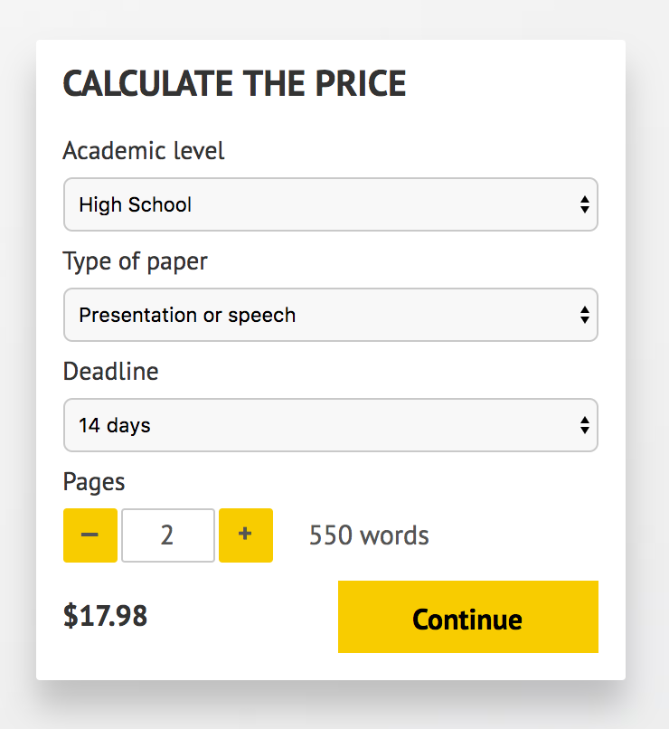](http://www.myspeechclass.com/go/custom-speech)

**IMPORTANT – PLEASE READ**

Don't use this speech as is! This document is available for anyone to download, and it has been used by *thousands* of people.

If you need help with writing a unique speech, please go to <http://www.myspeechclass.com/go/custom-speech> - you can order unique speech for as low as $17.98.