Internet Black Market

Zombies. Vampires. Werewolves. Halloween creatures are scary not because they are monsters, but because they look like they should be human and they're not. The Black Market is eerie because it looks like an ordinary business enterprise until you realize that the apple bin is full of human kidneys. Today I'd like to talk about the Black Market as hosted on the Internet - what it is, what people sell online, and how you can put it out of business.

We call the places you can buy illegal goods the "Black Market." On the Internet, the Black Market hangs out on thousands of anonymous servers across the globe, accessible only through specially programmed routers, which can only be accessed if you know how to connect to them. The Black Market sells all sorts of goods and services that you would never find anywhere else - narcotics, child pornography, hacking services, stolen identities, weapons, abductions, counterfeit money and so on. Because of the fluidity of the Internet, most Black Market transactions have been moved online so that law enforcement can't find the individuals behind it all. (1)

The Black Market on the Internet isn't limited to drugs, murder-for-hire, or body parts. The two most common goods on the Internet's Black Market are often free. I'm talking, of course, about piracy and plagiarism. The Music Industry estimates that the average iPod has $800 of pirated music. 42% of the software running on computers throughout the world were acquired illegally. The most pirated movie of all time is James Cameron's *Avatar*, and the most pirated TV show of all time is *Lost.* When 71,000 jobs and $2.7 billion dollars are lost in America alone due to Internet piracy, you know that there is a Market and a problem. (2)

Academic dishonesty is greatly aided by the Black Market on the Internet. While you may never have copy-pasted a Wikipedia article for your homework, educators find that students are increasingly outsourcing their homework to foreign sites. And plagiarism in its strict sense is only the tip of the iceberg - there are websites where you can buy 100% original, grammatically correct, and properly cited school papers. When turned in, these papers seem to be free from plagiarism; however, as it is not the student's personal work, educators still consider these works as plagiarized. Just as the Film and Music Industry hike prices because of piracy, teachers and professors have increased the amount of assignments in order to combat this phenomenon - which only perpetrates it further.

95% of all downloads from the Internet are illegal, and considered theft. You can make an impact on the Internet Black Market by simply buying music, and encouraging your friends to do the same. As far as plagiarism goes: just don't do it. If you feel overwhelmed, talk to your professors - they understand studenthood, and are more than willing to help. I know - it isn't as glamorous as busting a drug lord or breaking up a poaching gang (and if you're interested in those things, check out Innocent Justice or World Wide Fund for Nature), but it does make a difference. Stopping the Internet's Black Market really comes down to individual integrity - where individuals choose to live lives free of crime, and work to help their friends, family, neighbors, and strangers do the same. Thank you for your attention. (3)

# Q&A:

* What are some other things that seem normal, but aren't? Do those things scare you? Why/why not?
* Have you ever found questionable goods while shopping online? What were they/how did you know?
* Have you ever pirated music/movies? Why?
* What do you think is the relationship between biblical integrity and plagiarism?

1. Goodman, Kevin. "The Dark Net: The New Face of Black Markets and Organized Crime." *Huffington Post.* 16 Oct, 2013. Web. 29 Oct, 2014.
2. Go-Gulf. "Online Piracy in Numbers." *Go-Gulf.* 1 Nov, 2011. Web. 29 Oct, 2014.
3. NME. "Music industry claims 95% of downloads are illegal." *TimesIncUK.* 16 Jan, 2009. Web. 29 Oct, 2014.

[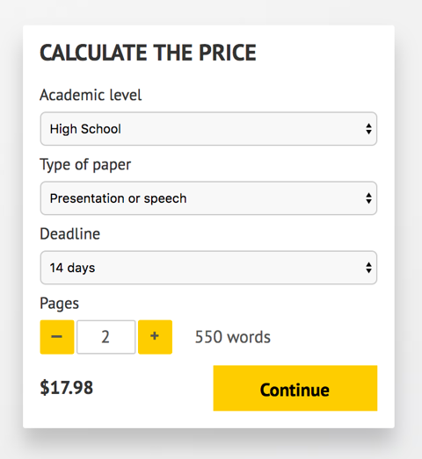](http://www.myspeechclass.com/go/custom-speech)

**IMPORTANT – PLEASE READ**

Don't use this speech as is! This document is available for anyone to download, and it has been used by *thousands* of people.

If you need help with writing a unique speech, please go to <http://www.myspeechclass.com/go/custom-speech> - you can order unique speech for as low as $17.98.