[Your Name]

[Instructor]

[Class]

[Date]

the danger of Plastic surgery

# Introduction

1. Attention Getter: If you could change anything about your physical appearance, what would it be? I’m sure that many of you have a number of answers to that question, and that’s a fact that we should be concerned about.
2. Topic Clarification: We’re living in a time of unprecedented expectations of body image, where many of us draw our self-worth from just the way we look. Unfortunately, this shallow social norm has been exacerbated by the development of cosmetic and plastic surgery. Now, the desire to look a certain way, and the dissatisfaction of looking the way we do, are fueled by the possibility of actual change.
3. Roadmap: Today, I will explain how this development is a danger we should counteract. First, I will describe the health problems related to the surgery itself. Then, I will explain how it contributes to the self-destructive culture of bodily perfection. Finally, I will examine how this represents a profound moral confusion for our society and ourselves.

# body

1. Main Point: The most immediate danger to be concerned with is that of the surgical procedure itself.
2. Many people fail to recognize that plastic surgeries are as dangerous and risky as any other major operation.
3. Personal injury attorney Mark Kaire writes that deaths related to anesthesia occur in 1 of 13,000 cosmetic operations, and deaths resulting from facelift procedures occurred in 1 out of 600 (Kaire 2013).
4. He furthers on the other complications can occur from these operations, generally from anesthetic use. These include heart irregularity, blood clots, nerve damage, stroke, heart attack, and brain damage (Kaire 2013).
5. When people are dying and suffering these extreme health problems, we can see that the risks of plastic surgery far outweigh the benefits.

[Transition: However, the fact that people are pursuing that benefit despite the risk is of much more fundamental concern.]

1. Main Point: Plastic surgery supports the culture of beauty perfection, which is extremely damaging to our society.
2. Sub Point: The body images portrayed by the media and aspired to in our culture have severe repercussions on our wellbeing.
3. British parliament member and the founder of the Campaign for Body Confidence, Jo Swinson, writes that people around the globe are succumbing to pressures to achieve an unrealistically ideal image.
4. She writes “that one in four people are depressed about their body,” and that “a third of women say they would sacrifice a year of their life to achieve the ideal body” (Swinson 2011).
5. Sub Point: This profound social issue is only intensified by plastic surgery.
6. People are exposed to artificial beauty under the expectation of achieving it themselves – or not being good enough if they don’t.
7. Additionally, people can rely on the possibility of plastic surgery to alter their appearance, deepening their desire to do so.
8. This means that plastic surgery and the unrealistic expectations on our physical appearance are mutually reinforcing, and should be advocated against.
9. Main Point: Yet in addition to being a danger to our personal and social health, plastic surgery presents a moral danger as well.
10. If our physical makeup is part of who we are, what does it really mean for us to change it?
11. What kinds of choices does it force us to make regarding our identities and ourselves, and how we interact with our loved ones, our children?
12. These kinds of questions jeopardize our moral character, risking what it means to be an individual and to be the way one is.

# CONCLUSION

1. Transitional Signal: We can therefore see that plastic surgery is frighteningly hazardous.
2. Summary: I’ve explained how it endangers our health, our social wellbeing, and our moral integrity.
3. Call To Action: It’s therefore up to us to take a stand on all of these issues. It’s up to us to consider whether our beauty and others’ perception of us are worth our health and happiness. It’s up to us to fully accept ourselves as we are.

# WORKS CITED

Kaire, Mark. (2013). Cosmetic Plastic Surgery Death Statistics.

Swinson, Jo. (2011). False Beauty in Advertising and the Pressure to Look 'good'. CNN.

[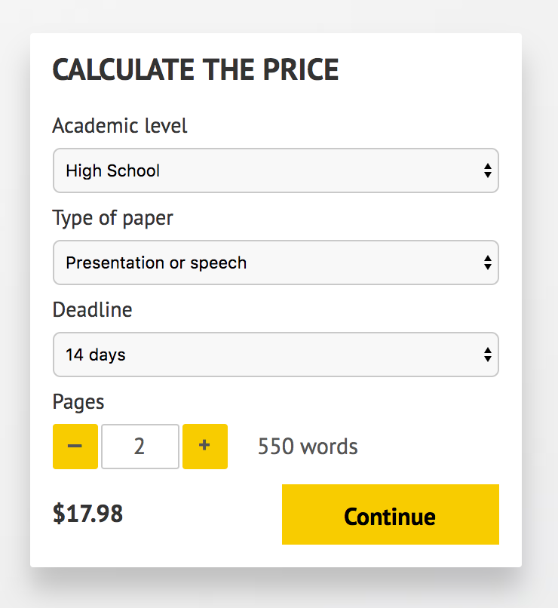](http://www.myspeechclass.com/go/custom-speech)

**IMPORTANT – PLEASE READ**

Don't use this speech as is! This document is available for anyone to download, and it has been used by *thousands* of people.

If you need help with writing a unique speech, please go to <http://www.myspeechclass.com/go/custom-speech> - you can order unique speech for as low as $17.98.