[Your Name]

[Instructor]

[Class]

[Date]

# Separation of Powers of the Federal Government

The purpose of my speech today, is to point out very clearly, why the Founding Fathers separated the powers relating to the Executive, the Judicial and the Legislative. People, including legal luminaries and others, have posited various reasons why they think the Framers of the Constitution saw it fit to do this. However, the facts are what will stand, and I hereby present them today.

Before I go any further, let us pause at this juncture, to point out the definitions of the terms Executive, Judicial and Legislative as indicated by reputable sources. Following this, I will say why the Founding Fathers saw it fit to have them separated, outline the functions of each and then say how the separation of powers works as a check and balance system on the other branches.

The Executive is defined as, quote, “The branch of the U.S. government that is composed of the president and all the individuals, agencies, and departments that report to the president…”end quote. (<http://legal-dictionary.thefreedictionary.com/Executive+Branch>)

The main duty of the Executive, is to ensure that the laws passed by congress are enforced. Some of this duty is executed by the President in Presidential Powers, while others come about through the departments, other individuals or agencies that help to constitute the Executive.

The Education Portal tells us that, quote, “The Judicial Branch is one of three branches of the federal government. The Judicial Branch includes criminal and civil courts and helps interpret the United States Constitution. (<http://education-portal.com/academy/>)

The interpretation of certain sections of the United States Constitution has been the source of much discussion and sometimes, controversy, since it was enacted more than three hundred years ago. However, the Judicial Branch has always had the final say, regarding the strict interpretations of these issues whenever they arise. After all, it deals with the Judiciary, which was put in place to handle such matters.

On the other hand, the Legislative is defined as the branch of government that consists of, quote, “the House of Representatives and the Senate, which together form the United States Congress.” End quote. (<http://www.whitehouse.gov/>)

Congress puts legislation in place based on authority given to it by the constitution. Three of the main things which it deals with are substantive investigations, the declaration of war and the rejection or confirmation of appointments by the President.

Over the years, the majority of appointments by the President have always been approved. However, there are times when they are either turned down or see more lengthy hearings in order to come to a positive decision.

Now let’s turn our attention to how the Executive, the Judicial and the Legislative, work as checks and balances for each other. The Founding Fathers deliberately ensured that the Constitution was framed in such a way that all three arms of the government would be independent of each other.

This helps each of them to keep the others in check. The independence that they have, also provides equity between them. This means that none of them can dominate the others. Of interest, is the fact that each of the three sections, have powers entrenched within them, to curtail the might, authority or power of the others.

The most stark examples of this, are as outlined here: quote, “The president can **veto** (prevent from becoming law) acts of Congress, Congress can override presidential vetoes, and the Supreme Court has assumed the power of judicial review.” End quote. (<http://www.sparknotes.com/us-government>)

Ladies and gentlemen, I have provided you with information about the three arms of government; namely, the Executive, the Judicial and the Legislative. You have been informed about why the Founding Fathers separated them. I have also pointed out the powers conferred on each branch and give a credible account of the checks and balances which they have towards each other.

Thank you.

[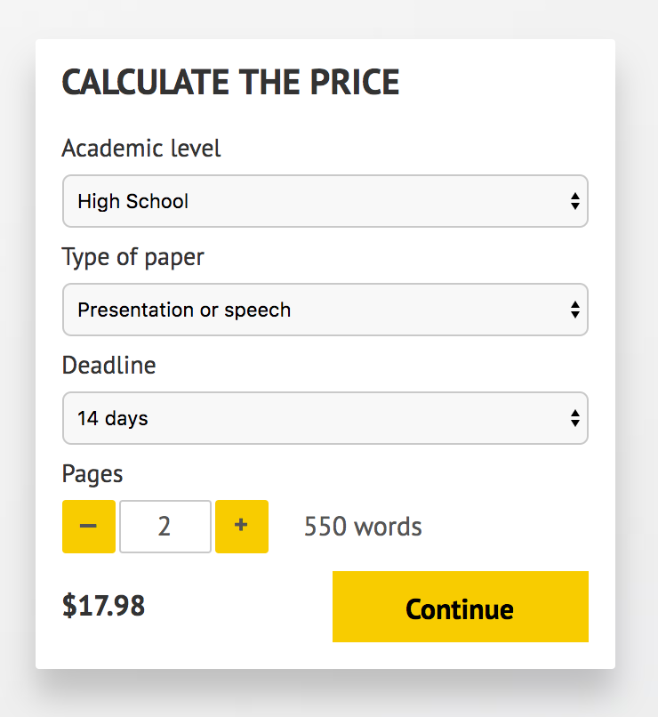](http://www.myspeechclass.com/go/custom-speech)

**IMPORTANT – PLEASE READ**

Don't use this speech as is! This document is available for anyone to download, and it has been used by *thousands* of people.

If you need help with writing a unique speech, please go to <http://www.myspeechclass.com/go/custom-speech> - you can order unique speech for as low as $17.98.