[Your Name]

[Instructor]

[Class]

[Date]

why android IS better than ios

**INTRODUCTION**

1. Background

Android versus iOS is one of the most recent rivalries in modern technology. As a matter of fact, there are those who claim that it defines what our generation calls the “smartphone war”. Over the years, Android and iOS have managed to surface as two of the most reliable operating systems for both tablets and smartphones in this age of technology. This is why as the Android versus iOS debate rages on, several arguments are being raised by those who belong to #TeamAndroid and #TeamIOS.

1. Significance

In our advanced world, having the right gadget to execute a specific set of tasks is a very important necessity. Today, I intend to look at five main reasons why Android is superior to iOS. A A

**REASONS WHY ANDROID IS BETTER THAN IOS**

Android is an open-source operating system engineered by Google which powers millions of devices all across the globe. Here are the following points that prove that it is indeed far better than iOS:

1. Quantity of Applications A A

First, if we will look at both systems from the technical perspective, it could be inferred that Android system offers more free applications than iOS. Generally speaking, the world is your oyster with Android because its play store has over 975,000 free applications while Apple only has about 900,000. Downloading songs from the Android market is also easier and more convenient than in iOS primarily because Android doesn’t really care where you get your songs from, unlike in iOS where iTunes is required before a user can load his or her phone with a bunch of songs.

1. Wider Sharing Capabilities and Visible File System

Next, in sharing files, Android offers countless sharing possibilities. Any Android user can share data by means of any installed app as opposed to iOS where the user is only allowed to choose from few basic options like Facebook, Twitter, Flickr, Gmail, and Message. Android also offers a strong and visible file system unlike iOS. For example, an Android user can plug his or phone to the computer, and transferring files would be as easy as drag-and-drop. This is a type of access iOS does not bring forth to its user’s files.

1. Better Avenue for Video Chats

When it comes to video chats, Android provides the best venue. Google Hangout on Android can be easily used to place video calls over Wi-Fi or 3G. iOS fails to grant this liberty to its users because although iOS’ Facetime can be used for video chats over Wi-Fi and 3G, it limits its users to communicate only with those who are owners of Apple devices. In this regard, it is clearly more convenient for phone users to use Android than iOS.

1. Customization

The fourth main edge of Android over iOS is that any user who wants to customize his or her smartphone can easily do so through the Android system. The sky is the limit with Android when it comes to altering whatever it is that the user wants - a choice which iOS doesn’t bestow upon its users.

1. Battery Life

Lastly, we ought to consider the importance of battery life. Before buying a phone, we always have to take into account how long we can use our gadget. If compared to iOS devices’ battery life, Android will definitely prove to be more favorable. This is because Apple devices are known for having poor battery life, and what’s worse is that iOS doesn’t introduce new feature updates to address its battery limitation. Android, on the other hand, has recently launched a battery saving mode which allows Android devices to have a longer battery life.

**CONCLUSION**

1. Summary

As you can easily see, Android is a much better operating system than iOS; and in order for you to make a well-informed and educated decision in choosing which mobile platform is the right fit for you. Keep in mind the five main points I have shared with you today. Android is better than iOS for various reasons. First, it offers a variety of applications. Second, it has endless sharing capabilities and a transparent file system. Third, it provides better venue for video chats. Fourth, it will allow you to do customization on your device. Lastly, Android allows the maximization of any device’s battery life.

1. Concluding Remarks

At the end of the day, it’s all about knowing your needs and satisfying those needs by choosing the right instrument which can effectively help you carry out your day-to-day tasks. Could Android help us to learn, discover, and work efficiently? Yes, it certainly could, better than any other system. Without a doubt, Android is the best platform in the market which can offer you the satisfaction which other systems like iOS won’t be able to. I’m going to leave you with Fred Wilson’s simple and truthful statement, “The mobile OS market will play out very similarly to Windows and Macintosh, with Android in the role of Windows. And so, if you want to be in front of the largest number of users, you need to be on Android.”

# SOURCES

Kelly, G. (2014, November 7). IOS 8 vs Android 5.0 Lollipop Review: Material Difference. Retrieved November 10, 2014, from http://www.forbes.com/sites/gordonkelly/2014/11/07/ios-8-vs-android-5-0-lollipop-review/

The reasons why iOS is better than Android - Woopa Design. (n.d.). Retrieved November 10, 2014, from <http://wdesign.co.nz/reasons-ios-better-android/>

[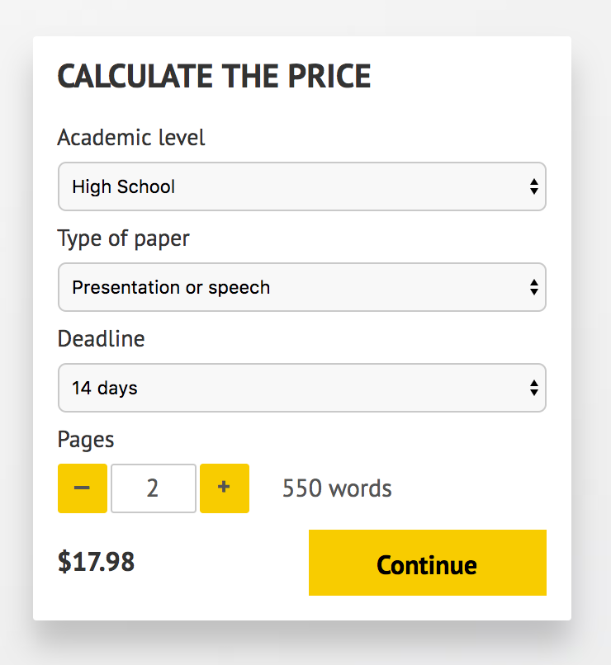](http://www.myspeechclass.com/go/custom-speech)

**IMPORTANT – PLEASE READ**

Don't use this speech as is! This document is available for anyone to download, and it has been used by *thousands* of people.

If you need help with writing a unique speech, please go to <http://www.myspeechclass.com/go/custom-speech> - you can order unique speech for as low as $17.98.