[Your Name]

[Instructor]

[Class]

[Date]

why android IS better than ios

**INTRODUCTION**

Some of you may be dreaming of owning a new iPhone 6 or 6 Plus to enjoy all those awesome promises you see on well-invested ads. Apple prides itself for being, presumably, the first to launch a touchscreen device. However, it has not maintained its post at the pedestal, especially that Android now offers more stuff than iOS does. So, now that Apple's new iOS 8 offers a lot of new features, which are sadly not that new for Android users, would iOS finally outrank Android? Let me show you three major points why iOS can’t be better than Android despite its many improvements this year. A A

**REASONS WHY ANDROID IS BETTER THAN IOS**

1. Android users have more freedom customizing their device A A

iPhone lovers just love Apple’s simplicity. Sure. Why bother using a device with so much to be complicated about? What more would you wish for if your phone already helps you make calls, send messages, browse the Web, play games, and use productivity apps which iOS makes the best out of?

iPhones are simple alright, until you need to put music in it and will be required to do it using iTunes. You would also need that special cable just to connect to the computer. Little complications you can certainly do without.

With an Android device, however, those little extras iOS lovers call complications are there to give you only more fun and freedom. When you get your Android 4 device, it offers a load of personalization options. You are free to customize your device in all ways possible just to turn it into something uniquely yours. Of course, you can just let your new phone look like a normal android device with its preset interface. But what makes Android cooler than iOS is the fact that you can customize it in so many different, crazy ways, even if you don’t have to

1. Android offers more applications, file and media management

With a visible file system, you’ll be able to work with your android device as if you were searching for files on your computer. Just drag-and-drop files and folders to places you want them to be. Apple, on the other hand, just can’t give you that kind of access to all your files.

Furthermore, Android users can just insert up to 128GB more room to store videos, photos, music, and apps with a simple MicroSD card. Apple, on the other hand, requires as much as 5.8GB of free space before it will allow you to upgrade your iPhone to iOS 8, causing deletion anxiety among users. If only they could store their files on a MicroSD card!

With your Android device, you don’t just secure your files in that tiny card. You also enjoy endless sharing options with your files. With iOS, however, you only can only share contents via Mail, Twitter, Facebook, Message and all those super basic choices.

And here’s another thing yet, most contents and apps for Android are usually either cheap or free

1. Android’s more “open” platform gives it more potential to win the competition against iOS.

Apple’s iPhone has gained so many followers because it claims to be the first touch screen device available in the market. So, by the time Android caught up with iOS in terms of effectiveness and quality, iOS was already better at infrastructure and app support.

But these past few years, Google is evidently getting better at developing its OS. In a short span of time, Android has started to operate more efficiently while upgrading its earlier versions. The main problem that Android is facing isn’t even about the software.

In some aspects, iOS stays snappier and faster by default. However, Android devices will always have more potential which will eventually break out. Its more “open” platform renders it so much potential yet to be freed.

**CONCLUSION**

Some people don’t like to handle too much techy stuff. So, for those who don't understand how to use a real OS, Apple gladly comes to the rescue. But for those who actually like to use their device to the fullest, Android is still the better.

# SOURCES

Ion, F. (September 23, 2014) 10 Android features that still make it better than iOS 8 Retrieved at: <http://www.greenbot.com/article/2686006/10-android-features-that-still-make-it-still-better-than-ios-8.html>

Android L vs iOS 8: what's different? Robot vs fruit By Gareth Beavis (1st Jul 2014) <http://www.techradar.com/news/software/operating-systems/android-l-vs-ios-8-what-s-different--1255053>

5 Reasons Why Android Is Objectively Better Than iOS (For The Power User) <http://whatculture.com/technology/5-reasons-why-android-is-objectively-better-than-ios-for-the-power-user.php/6>

[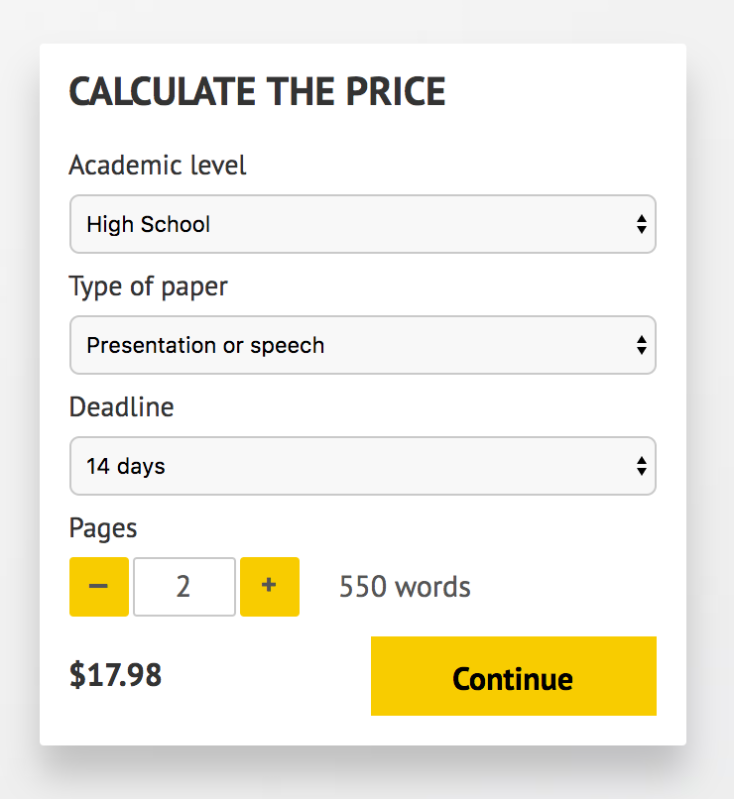](http://www.myspeechclass.com/go/custom-speech)

**IMPORTANT – PLEASE READ**

Don't use this speech as is! This document is available for anyone to download, and it has been used by *thousands* of people.

If you need help with writing a unique speech, please go to <http://www.myspeechclass.com/go/custom-speech> - you can order unique speech for as low as $17.98.