[Your Name]

[Instructor]

[Class]

[Date]

Everyone Should Learn to Play an Instrument

# Introduction

So let's say you want to become rich, famous, and adored by a vast majority of the world. You've got some options. You could write a great book. You could play the lead for an expensive movie. Or you could become a rock star. While it's unlikely that you'll ever do any of those things and become rich and famous, but each of those things on their own add an incredible amount of value to your own life personally. Today, I want to tell you why everyone should learn to play an instrument if they want to better themselves.

# BODY

1. Playing an instrument improves your physical body

Playing an instrument improves your physical control and well-being. Instruments require varying levels of both stamina and physical prowess to play. If you've ever been to a concert and watched the drummer, you've seen this in action -- by the end of the first two songs, most drummers are drenched in sweat. Researchers from the University of Chichester found that touring drummers burn an average of 300 calories per hour, and lose a quart of body fluids in that same timeframe. Drumming might be an extreme example, but playing any instrument while standing strains your whole body.  
Playing an instrument also improves your coordination. Drumming comes to mind as an extreme example of coordinating four limbs to operate independently at once, but even the piano takes a high level of hand-eye coordination to play well. Instruments train you to move smoothly, quickly, and precisely as you learn to keep rhythm while playing the correct notes.

1. Playing an instrument improves your mind

As physical as instrumental hand-eye coordination is, it's also a mental exercise. Learning chords, rhythm patterns, and reading music enhances your mind. Playing an instrument can increase your memory, improve your organizational skills, and refine your math and reading abilities. As an example, let's say you're playing the guitar and learning how to play Crazy Train. First, you have to decide how you want to learn the song -- do you go from beginning to end, or do you break it up into parts and learn them in order of difficulty? Then you have to memorize the individual parts and how to play them in order. You learn the chords by *reading* a chord chart, and as you learn how long to hold the chords, you practice your math.

1. Playing an instrument improves your emotional state

Emotionally, playing an instrument also helps create a better version of you. You start by learning how to play songs that mean something to you, which relieves tension, and eventually you can write your own songs that give you emotional release. This can also create a healthy sense of achievement. Learning an instrument in and of itself creates this achievement, for it takes talent and hard work to play well, but creating your own music is another high bar to jump over. Leaping over it successfully creates a sincere and lasting sense of joy and catharsis.

If you want to increase your social skills, you should pick up an instrument. Music is made alone, but is most beautiful and enjoyable when done in conjunction with others. Creating music well boosts your confidence, and doing so in a group setting creates bonds of friendship and self-worth.

# CONCLUSION

Playing an instrument is highly beneficial to your body, mind, and soul. Every healthy person seeking to better themselves should play an instrument to help them be the best person they can be. All that being said, there's really no way to know whether picking up an instrument will lead you to becoming rich and famous. It might not; after all, there are millions of musicians in the world. Then again, it might -- Taylor Swift, Ylvis, and One Direction have demonstrated that for us. The only way to find out, of course, is to choose an instrument to learn and then see where it goes from there.   
Thank you for your attention.

# WORKS CITED

Matthews, Michael. 28 Aug, 2011. "18 Benefits of Playing a Musical Instrument." *Effective Music Teaching*. Web. 14 Nov, 2014. <<http://www.effectivemusicteaching.com/articles/directors/18-benefits-of-playing-a-musical-instrument/>>  
  
McManis, Sam. 27 Dec, 2009. "Want a Great Workout? Try Drums." *Chicago Tribune*. Web. 14 Nov, 2014. <<http://www.chicagotribune.com/sns-health-use-drums-for-workout-story.html>>

[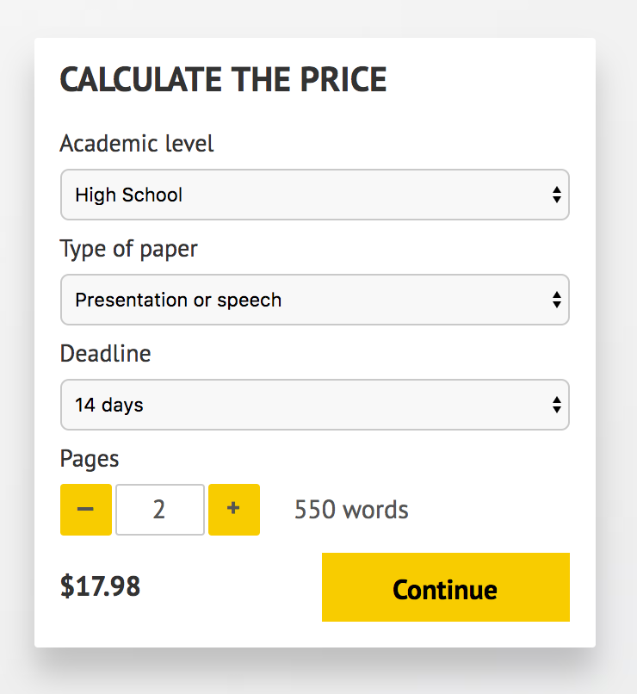](http://www.myspeechclass.com/go/custom-speech)

**IMPORTANT – PLEASE READ**

Don't use this speech as is! This document is available for anyone to download, and it has been used by *thousands* of people.

If you need help with writing a unique speech, please go to <http://www.myspeechclass.com/go/custom-speech> - you can order unique speech for as low as $17.98.