[Your Name]

[Instructor]

[Class]

[Date]

WHY YOU need to QUIT DRINKING SODA TODAY

# Introduction

From the comfort of your home to the school cafeteria, to the movies and everywhere else in the planet, soda is there, enticing us with its refreshing taste. Even if you want to drink something else, you will often have a hard time finding anything other than soda.

For many people, drinking soda several times a day is something normal. But the delicious liquid is actually ruining your health, and I’m going to explain you why you should quit drinking soda.

# body

1. Soda is very bad for your health
2. Soda has a lot of sugar and empty calories.

A single serving of soda contains an equivalent of 17 teaspoons of sugar. This sugar is to be turned into calories, which will most likely go straight into your system in the form of fat. According to Dr. Christopher Ochner, assistant professor of pediatrics and adolescent medicine at the Icahn School of Medicine, calories coming from sugar turn to fat more easily than calories coming from other types of food.

Ochner explained that when individuals drink a lot of calories, their bodies don’t register fullness as quickly as when they eat the calories. Therefore, they tend to drink more and more soda without getting a signal from their bodies to stop.

1. Sugar consumption leads to Type 2 Diabetes.

When we drink lots of sugar, our bodies wind up spiking and crashing, and our body’s system goes up and down in an effort to regulate the sudden rise of sugar contents in our body. Dr. Ochner explains how this whole process could ruin our body’s ability to metabolize sugar, makes us insulin resistance and we eventually end up with diabetes.

1. Soda leads to adverse heart conditions.

While soda gives us so many calories that have no nutritional value and lead to obesity, experts found out that soda contributes to cardiovascular diseases and stroke independent from excessive caloric intake.

Dr. Mary Ann McLaughlin, medical director of the cardiac health program at Mount Sinai explained that aside from the obvious bad effect of excessive sugar, it’s actually the latter two ingredients that have the worse effect to the heart. She further noted how caffeine increases heart rate and blood pressure, while too much sodium increases food retention. This combination has a dehydrating effect to the already thirsty person. This also means that even diet soda is still bad for your heart.

1. Soda is bad for your bones.

According to a Harvard review on several studies, soda may pose a unique challenge to our bones. Soda contains high levels of phosphate and too much of this chemical harms bone health.

II. Everybody needs to quit drinking soda today.

1. Cut down on soda gradually.

The old habit of drinking soda might be hard to break, so people should start with more achievable goals. You may start decreasing the frequency or the amount of your soda intake. Do not upsize your soda drink and eventually change what drink you’re ordering with your meal.

1. Drink more water.

When you’re thirsty, nothing quenches it better than water. So keep water bottles ready to go in your refrigerator and take one with you as you get out of the house.

1. Remind yourself what you’re getting.

Finally, every time you’re tempted to get yourself an extra-large glass of soda, remind yourself of its adverse effects to your health. Would you drink 17 teaspoons of liquid sugar in just a few minutes? Would you let all those caffeine and phosphate harm your body repeatedly throughout the day?

# CONCLUSION

It might be very hard to quit from something that tastes good and omnipresent in our society. But when you really think of its real effects to your health, all your efforts to quit would be very worth it.

# Works cited

Harvard School of Public Health. (2014). Soft Drinks and Disease. Retrieved from <http://www.hsph.harvard.edu/nutritionsource/healthy-drinks/soft-drinks-and-disease/>

Grush, L. (2013 August 7). Soda: Public health enemy No. 1? Retrieved from <http://www.foxnews.com/health/2013/08/07/soda-public-health-enemy-no-1/>

Magee, E. (2014). How Can I Stop Drinking So Much Soda? Retrieved from <http://www.webmd.com/diet/features/how-can-i-stop-drinking-so-much-soda>

[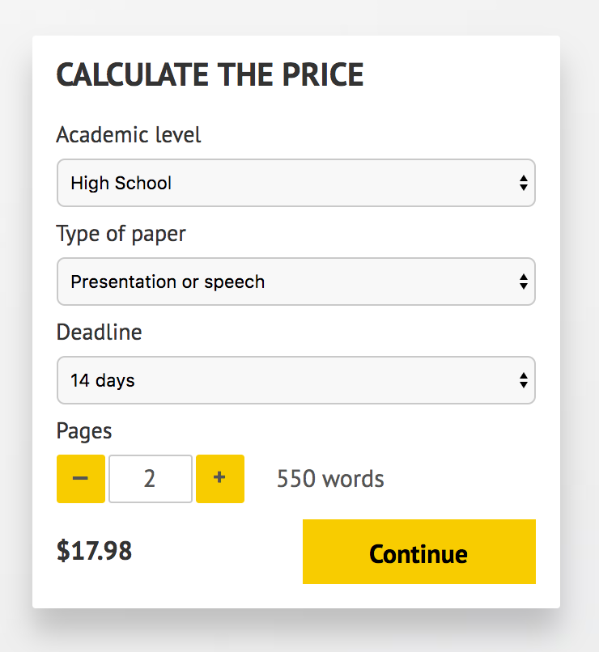](http://www.myspeechclass.com/go/custom-speech)

**IMPORTANT – PLEASE READ**

Don't use this speech as is! This document is available for anyone to download, and it has been used by *thousands* of people.

If you need help with writing a unique speech, please go to <http://www.myspeechclass.com/go/custom-speech> - you can order unique speech for as low as $17.98.