[Your Name]

[Instructor]

[Class]

[Date]

Diabetes

# Introduction

As health conscious as our media tells you to be, the truth is that this past weekend you probably stuffed your face with Thanksgiving food. And with Christmas coming up around the corner, you're likely not going to stop stuffing yourself any time soon. I mean come on, who says no to Gramma's cookies? A lot of people I know like to joke with me that they're getting "diabeetus," and continue to load up their plate with cookies, pies, and cakes. As funny as "diabeetus" is, diabetes is no laughing matter. Today, I'm going to tell you more about this disease, how you can get it, and why you might want to think twice before loading up from the dessert bar for the fifth time.

# Body

1. Kinds of Diabetes

There are three types of diabetes: type 1, type 2, and gestational diabetes. Diabetes is essentially a failure on the body's part to produce or use insulin to manage blood-sugar levels. This can happen through a couple of ways: either you are genetically wired so that your body destroys the cells that produce insulin in your body and you literally have to take insulin in order to live a healthy life, or your body produces insulin but cannot use it to fully manage the sugar in your blood. Gestational diabetes is when a pregnant woman has too much sugar in her blood due to the hormonal changes in having a baby.

1. Why it's bad

"What's so bad about having high blood sugar?" you ask. Well, blood sugar connects to hemoglobin (the thing that carries oxygen around your body), and weighs it down and makes it stiff and sticky. Not only can the hemoglobin not do its job when your blood sugar is too high, but it can also get dragged down and start building cholesterol in your blood vessels. High blood sugar can cause things such as strokes, heart attacks, nerve damage, blindness, kidney failure and gum disease. Not all diabetics are going to go blind or stop being able to feel things on their skin etc., but the longer they have untreated diabetes, the higher their risk for death.

1. Type 1

That being said, 10% of Americans with diabetes are type 1 -- their body literally cannot produce insulin for whatever reason. Whether its because their body breaks down the cells in their pancreas that are responsible for making insulin, or some other genetic disease destroys those cells, type 1 diabetes is almost always genetically passed down from the parents to their children. These children can live normal lives, if they take care of themselves and get insulin shots, eat well, and exercise regularly.

1. Type 2

The other 90% of Americans have type 2 diabetes. Type 2 can be genetically passed down, but usually has more to do with lifestyle choices. People who are over 45, obese, don't exercise, or have high blood pressure are far more likely to get type 2 diabetes than other people. Type 2 diabetes is the reason why you might want to pass on copious amounts of dessert. When you have too much blood sugar in your bloodstream at once, even if you create insulin you can be at risk for the dangers of high blood sugar. If you slam your bloodstream with too much sugar, your body may not be able to cope, which can lead to type 2 diabetes.

# Conclusion

I don't expect that my discussion on diabetes will really cause you to eat less of your Grandma's cookies, but I do hope it will help you make better decisions and be more sympathetic to people with diabetes. That being said, you might want to keep joking about "diabeetus" if you snack while studying for the oncoming finals… Thank you for your attention.

# WORKS CITIED

"What is Diabetes? What Causes Diabetes?". *Medical News Today.* Web. 4 Dec, 2014. <<http://www.medicalnewstoday.com/info/diabetes/>>

"Diabetes Guide." *WebMD.* Web. 4 Dec, 2014. <<http://www.webmd.com/diabetes/guide/default.htm>>

Davidson and Moreland. "Why high blood sugar is bad." *Mayoclinic.* 2 March, 2011. Web. 4 Dec, 2014. <<http://www.mayoclinic.org/diseases-conditions/diabetes/expert-blog/high-blood-sugar/bgp-20056519>>

[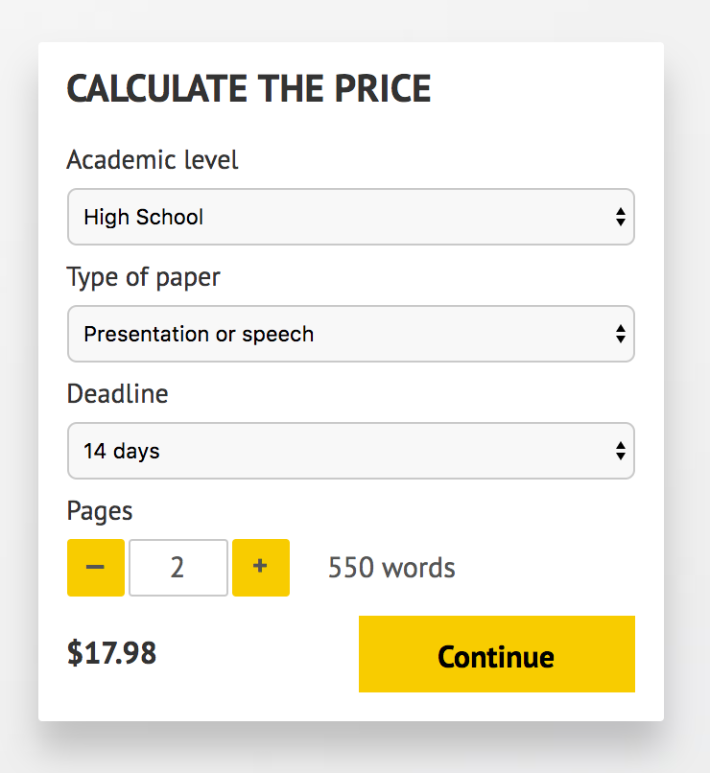](http://www.myspeechclass.com/go/custom-speech)

**IMPORTANT – PLEASE READ**

Don't use this speech as is! This document is available for anyone to download, and it has been used by *thousands* of people.

If you need help with writing a unique speech, please go to <http://www.myspeechclass.com/go/custom-speech> - you can order unique speech for as low as $17.98.