[Your Name]

[Instructor]

[Class]

[Date]

Three Reasons Why A State Should Not Drug Test A Welfare Applicant

# Introduction

Mandatory drug testing for welfare applicants has been becoming popular in the U.S. in the past few years. Proponents of this bill argue that government money shouldn’t be wasted on welfare claimants who would only use it on drugs. It does make sense, actually. But it is far from being flawless.

When we take a look at its effect to individual welfare applicants, we’ll have a clearer understanding of the true nature of this bill. One good example if the story of a 35-year-old Navy veteran who had to go through a difficult phase in life. In 2011, Luis Lebron was having a hard time making ends meet because he was sending himself to college, at the same time raising a kid and taking care of his aging, disabled mother. Lebron decided to apply for TANF benefits and went to the welfare hoping to receive $241 monthly to help him get by. The state’s reply? “Pee into this cup so we can make sure you're not going to spend the money on drugs.” Being an honorable citizen, Lebron refused to be treated in such a humiliating manner just for a bit of cash. The result? He was denied public assistance.

# body

1. Welfare applicants are not more likely to use drugs than other people.

It is true that the state (or any sane organization at all!) shouldn’t give drug money to people. But what makes them assume that welfare applicants would use the money on drugs? Are the poor more likely to use drugs than any other groups?

Well, several studies, including a report from the National Institute on Alcohol Abuse and Alcoholism have found out that the welfare applicants and other groups of people do not have any significant difference when it comes to the use of illegal drugs. Another study conducted to people ages 18 to 49 revealed that 70% of illegal drug users are those who are employed full time. Yes, those who don’t need welfare assistance are those who are most likely to be on drugs.

1. Drug testing only wants to stigmatize the needy.

So, if these studies have revealed such enlightening results, why go on stereotyping the poor as drug users? And why aren’t we drug testing other people? If we are so careful about not spending any government money on drugs, why aren’t we drug testing Harvard students who get federal student loans?

Based on Florida’s experience, the state doesn’t save any money while trying to keep drug users off welfare benefits. WFTV, a Florida local TV station, reported that only two out of the 40 drug tested applicants tested positive. While the state saves $480 a month on two applicants, it had to pay $1140 to the applicants who tested negative.

Given that cost-benefit reality, we can say that what really is behind the drive to drug-test welfare applicants is the state’s desire to stigmatize the needy.

By picking the poor out of the many other groups who might also be spending government money on drugs, the state separates them from the rest of society, treating them as if they have less right to privacy just because they’re having difficulty making ends meet.

1. Drug testing is unconstitutional.

In 1997, in Chandler v. Miller, the Supreme Court voted 8-1 to strike down a Georgia law requiring applicants for state offices to pass a drug test.

Justice Ruth Bader Ginsburg said that the state can impose drug tests only when there is a public-safety need for them. The Fourth Amendment prohibits the state to diminish “personal privacy for a symbol’s sake.”

# CONCLUSION

If a state is really concerned about drug abuse, it should just find other means to solve the problem and better enforce its policies on all of its population and not just on a particular group, especially not on those who are in need and are already feeling vulnerable. The state should not inflict further moral damage to those who come to its doorstep for help, or it might end up like Florida which Luis Lebron sued and won over.

# WORKS CITED

Cohen, A. (2011 August 29). Drug Testing the Poor: Bad Policy, Even Worse Law. Retrieved from <http://ideas.time.com/2011/08/29/drug-testing-the-poor-bad-policy-even-worse-law/>

Williamson, J. (2014 January 2). Florida Cannot Drug Test People Simply Because They’re Poor. <https://www.aclu.org/blog/criminal-law-reform-racial-justice/florida-cannot-drug-test-people-simply-because-theyre-poor>

Bloom, R. (2011 October 12). Poor People Have Rights Too. <https://www.aclu.org/blog/criminal-law-reform-racial-justice/poor-people-have-rights-too>

[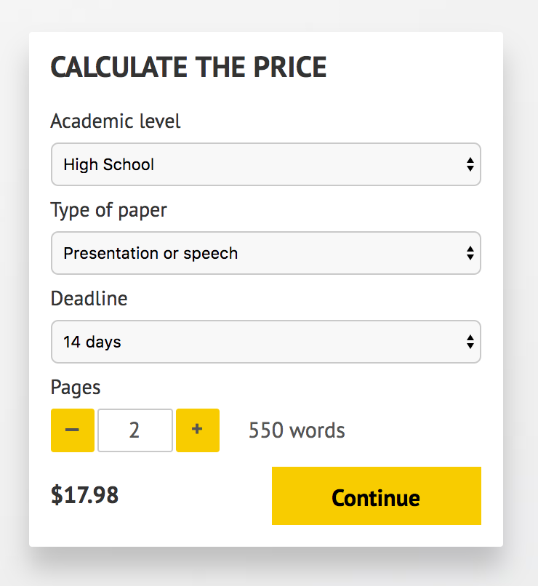](http://www.myspeechclass.com/go/custom-speech)

**IMPORTANT – PLEASE READ**

Don't use this speech as is! This document is available for anyone to download, and it has been used by *thousands* of people.

If you need help with writing a unique speech, please go to <http://www.myspeechclass.com/go/custom-speech> - you can order unique speech for as low as $17.98.