[Your Name]

[Instructor]

[Class]

[Date]

RAISE MINIMUM WAGE, SAVE THE BURNING HOUSE

# Introduction

To start off today, we're going to take a little class poll. The scale is 1 to 10, with 1 being awful, and 10 being awesome. Using your ten fingers, please rate the health of the American economy. If you think America is flourishing, I want to see tens, if you think America is headed the way of Rome, show me ones. Hold up your hands high. Now, take a look around the room and see what your peers think of our economy. Whether or not you're an economics major or interested in politics, you can see that our economy isn't doing great. Sure, it's better than 2008, but only a few people said that they think our economy is objectively healthy. To improve our economy, I'm going to argue that we should raise minimum wage.

# Body

1. About minimum wage

The federal minimum wage is $7.25. Now each state has a say in its minimum wage, and if the wage is higher than the federal one, they can force businesses to pay their wage. For example, California's minimum wage is $9.00, and is set to be $10.00 by 2016. However, despite these laws, there are many different kinds of businesses and employees that are exempt from minimum wage, such as employees with disabilities, federal criminal investigators, and newspaper deliverers.

1. What is minimum wage for?

Minimum wage is set to help protect younger workers, and ensure that poverty is limited, especially among ethnic groups. The idea behind minimum wage is that someone who makes minimum should be able to provide for themselves and a family without tipping into poverty. However, these goals for minimum wage are not being met: 45 million people (14.5%) are living at or below the poverty line in the United States. Many of these people are students just out of college, and ethnic families, the very people minimum wage is supposed to help and protect. This shows that the current minimum wage is insufficient, and needs to be raised.

1. Minimum wage alone isn't enough

Problems arise when we simplify all of our economic solutions to "raising minimum wage." We can't just raise minimum wage and expect everything to be hunky-dori, for poverty to disappear and prosperity to return. That's like sitting in a burning house and blowing out a candle -- yeah, you put out a fire, but you're nowhere close to saving the house. Raising minimum wage has to be done in conjunction with other drastic measures. What measures could be taken in conjunction?

Really, the most effective measure is that as we raise the minimum wage, we have to decrease the maximum wage. If you're thinking that's un-American and impossible, you're right, but hear me out. If we raise minimum wage, all we're doing is increasing the number of dollars that it takes to be considered poor. The poverty range starts at $30,000 for a five-member family. That, and many impoverished Americans still have access to things like running water, a TV, a car, etc. But really, if you want to improve the economy, you have to balance the playing field, and our economic playing field is absolutely out of balance. The top 1% is making $1.4 million a year and the bottom 99% barely makes $100,000 a year. Almost 90% of America's wealth is owned by 20% of the people.

# Conclusion

1. Minimum wage, yes, but more than that

With numbers like that, it should be clear that we need to raise minimum wage, if only just to spread the wealth more evenly. However, raising minimum wage is insufficient by itself, and lends to creating unnecessary inflation: as necessary as it is, we need to take more actions to truly solve our economic health problems and save our burning house while we still can. Thank you for your attention.

# Works Cited

Desilver, Drew. "U.S. Income Inequality, On Rise For Decades, is Now At Highest Since 1928." *Pew Research.* 5 Dec, 2013. Web. Retrieved 25 Nov, 2014. <<http://www.pewresearch.org/fact-tank/2013/12/05/u-s-income-inequality-on-rise-for-decades-is-now-highest-since-1928/>>

Doyle, Alison. "Minimum Wage Exemptions," "Minimum Wage Rates for 2014." *About Career.* Web. Retrieved 25 Nov, 2014. <<http://jobsearch.about.com/od/minimumwage/a/minimum-wage-rates-2014.htm>, <http://jobsearch.about.com/od/minimumwage/g/minimum-wage-exemption.htm>>

U.S. Census Bureau | Social, Economic, and Housing Statistics Division: Poverty |  Last Revised: September 16, 2014. Web. Retrieved 25 Nov, 2014. <<http://www.census.gov/hhes/www/poverty/>, <https://www.census.gov/hhes/www/poverty/about/overview/measure.html>>

[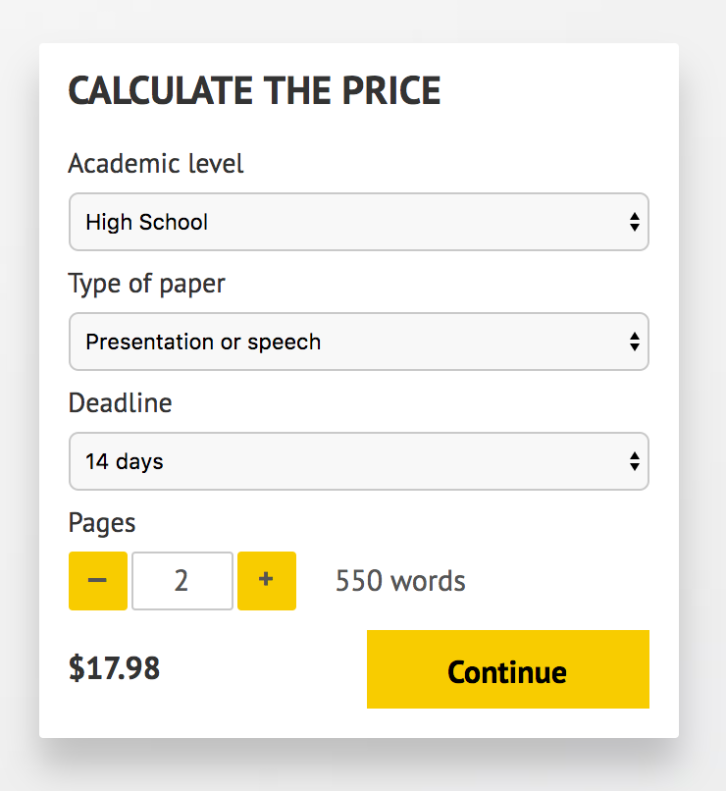](http://www.myspeechclass.com/go/custom-speech)

**IMPORTANT – PLEASE READ**

Don't use this speech as is! This document is available for anyone to download, and it has been used by *thousands* of people.

If you need help with writing a unique speech, please go to <http://www.myspeechclass.com/go/custom-speech> - you can order unique speech for as low as $17.98.