[Your Name]

[Instructor]

[Class]

[Date]

why minimum wage should be raised

# Introduction

Workers across the United States have been demanding an increase in minimum wage. Who wouldn’t be happy earning a little bit more for an honest day’s work? Many, however, oppose to it saying that people don’t realize how raising minimum wage would negatively impact workers, businesses and the U.S. economy in general. However, I’ve come across lots of reasons why they are wrong and I will present you with three of them.

Body

1. Minimum-wage workers earn 25% less in inflation-adjusted terms compared to their counterparts 45 years ago.

The federal minimum wage was raised to its current level of $7.25 per hour more than five years ago. Over that time, the real value of $7.25 has fallen nearly 10% due to rising prices. Yet, compared to the past four decades, this decline is still small. Since 1960, the minimum wage had been so infrequently and inadequately raised that today’s minimum wage doesn’t anymore match people’s needs. Because of inflation, the value of earnings of today’s workers 25% less than their counterparts 45 years ago.

1. Increasing minimum wage will boost the economy.

While some opponents of minimum wage raise argue that the increase will negatively impact the economy because of the amount of money that businesses will have to lose over workers’ wages, most businessmen surveyed actually think otherwise.

Frank Knapp, Jr, president and CEO of the South Carolina Small Business Chamber of Commerce, said that minimum wage increase would be good for the economy because it would put more money in the hands of Americans who make less than $10.10. Once these minimum wage earners get to spend more, they will be spending money, improving local economies. Other employees will also enjoy salary adjustments, also enabling them to spend more money.

Furthermore, the government will not have to spend as much money on welfare as they do now since the poor will be given a little financial freedom already.

1. Contrary some analysts’ warnings, increasing minimum wage will not increase unemployment.

Daniel Mitchell of the Cato Institute said that young people and minorities would suffer from unemployment because businesses would only create jobs when they think a worker could generate net revenue. Once minimum wages get higher, however, a lot of jobs would be closed and more people would be unemployed.

Pi Pizzeria, a successful businessman of a chain of restaurants, thinks otherwise. He recently voluntarily raised his workers’ minimum wage to $10.10 an hour. The end result is increased employment and not layoffs. His business also saved a lot of money by reducing employee turnover which then saved him training cost for new workers.

If you’re paid well, you know your employer values your work. You’d be happy to stay working with the company. The longer you stay, the more experience you get. And when you’re more experienced, you become better at your job. You’re happy with your pay and your employer is even happier with your performance, yielding profits for his business here and there.

# Conclusion

It’s really about time the federal government takes a positive stand towards raising the federal minimum wage. People today should earn enough to live. But if their wages do not match the inflation rate, there can never be a fair compensation for an honest day’s work. Increasing the minimum wage will not only help honest workers. It will also help boost the economy and help businesses grow though quality employment.

# Works Cited

Gillikin, J. (2014). *Problems With Minimum Wage*. Retrieved from <http://smallbusiness.chron.com/problems-minimum-wage-2692.html>

Cooper, D.(2014 October 16).*Raising the Federal Minimum Wage to $10.10 Would Save Safety Net Programs Billions and Help Ensure Businesses Are Doing Their Fair Share*. Retrieved from <http://www.epi.org/publication/safety-net-savings-from-raising-minimum-wage/>

Eisenbrey, R. (2014 October 20). Businesses Agree—It’s Time To Raise the Minimum Wage. Retrieved from <http://www.epi.org/blog/businesses-agree-time-raise-minimum-wage/>

[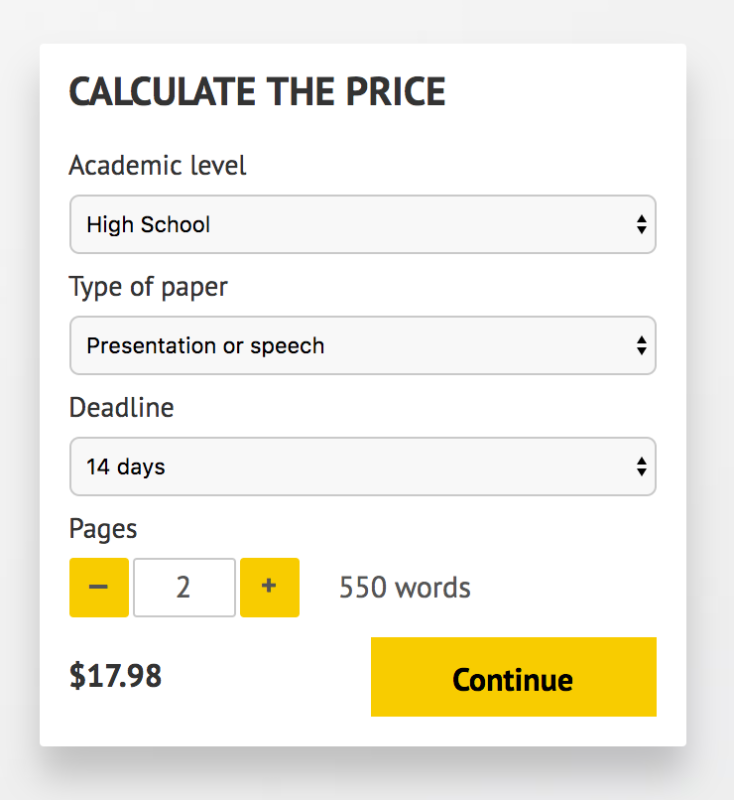](http://www.myspeechclass.com/go/custom-speech)

**IMPORTANT – PLEASE READ**

Don't use this speech as is! This document is available for anyone to download, and it has been used by *thousands* of people.

If you need help with writing a unique speech, please go to <http://www.myspeechclass.com/go/custom-speech> - you can order unique speech for as low as $17.98.