[Name]

[Date]

[Class]

[Professor]

Cultural Influences on Eating Disorders

# Introduction

Our society’s standards for beauty nowadays have been so distorted by media that ideal beauty has become impossible for normal women to achieve. Yes, the ideal beauty has turned into an impossible combination of made-up standards that many sort to drastic measures just to feel accepted by their peers and be admired by society.

In a survey sponsored by People Magazine, 80% of women respondents said that images of women on television and in the movies make them feel insecure. Furthermore, four out of five US women are dissatisfied with their appearance.

Is it because 80% of American women are unattractive? We know that is not the case. But because our need for belongingness and approval is so great, especially during adolescence, many young people realize they just cannot achieve our standards for beauty, making them feel inadequate and ugly.

# Body

1. What is an eating disorder?

In our society, you’ve got to be as skinny as possible to be considered sexy. No wonder many would starve themselves and feel guilty for consuming the calories their bodies need to function well.

Eating Disorders refer to a range of conditions which involve an obsession with appearance, weight and food to the degree that one’s daily activities, interactions and health become adversely affected. Some victims of eating disorders restrict food intake, some binge on food, some purge themselves after binging and abuse laxatives. There are those who compulsively overeat while others exercise excessively. When untreated, eating disorders can cause physical problems, mood swings, and even potential death.

In the US alone, about 10 million women and 1 million men suffer from an eating disorder. Women are especially prone to having eating disorders while the number of men with the condition has also grown considerably in last ten years.

1. What are the factors behind eating disorders?

Eating Disorders are not just about weight and food issues. These conditions often develop as a way of coping with depression, stress, emotional pain, and low self-esteem.

Many people suffering from eating disorders seem emotionally healthy, enjoy success and seem happy with their lives. According to Eating Disorder Foundation, the condition is an external solution to inner turmoil. One’s inner turmoil may be caused by feelings of inadequacy, anxiety, anger and loneliness. Some are caused by problems with personal relationships, being ridiculed or having experienced physical and sexual abuse. In almost all of these psychological factors, low self-esteem can be a cause or an effect of any of them.

Scientists are still trying to find out the biological causes of eating disorders, perhaps some chemical imbalance in the brain that make people lose control over hunger and appetite. But strong evidence is yet to be established.

1. How do cultural influences affect people’s self-image?

People’s low self-esteem and all the psychological issues related to the problem are strongly influenced by a person’s socio-cultural background. We will see how strongly our pop culture affects people’s ideals in a study published in 1999 which exposed people in Fiji to Western television for 38 months. Before they watched television, the participants believed that the ideal body was round, plump and soft. After the experiment, however, interviews reveal that there was a sharp decrease in their self-esteem. Furthermore, an increase in symptoms of eating disorders had been observed among teenage girls.

These teenage girls in Fiji had only been exposed to our culture for 36 months and they already developed lower self-esteem and manifested symptoms of eating disorders. Now, consider what effect our culture has on us who have been wallowing in our thinness-glorifying culture all our lives.

# Conclusion

Our cultural norms determine people’s worth in terms of physical appearance, while generally ignoring inner qualities and strengths. Because our culture’s ideals for beauty are impossible to achieve by any healthy means, those who are emotionally vulnerable, those who seek more attention and acceptance, those who feel insecure only want to give society what it requires.

# Works Cited

The Eating Disorder Foundation. (2013). *About Eating Disorders*. Retrieved from <http://www.eatingdisorderfoundation.org/EatingDisorders.htm>

Hanlon, K. (2014). *What Is The Relationship Between Low Self-Esteem and Eating Disorders ?* Retrieved from <http://www.vanderbilt.edu/AnS/psychology/health_psychology/esteem.htm>

Engel, B., Reiss, N., & Dombeck, M. (2014). *Causes of Eating Disorders - Cultural Influences.* Retrieved from <http://www.sevencounties.org/poc/view_doc.php?type=doc&id=11752&cn=46>

[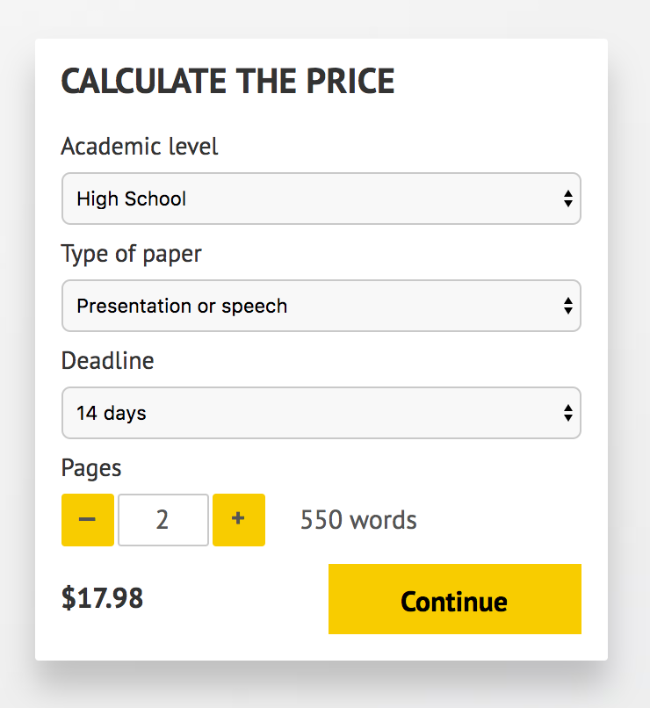](http://www.myspeechclass.com/go/custom-speech)

**IMPORTANT – PLEASE READ**

Don't use this speech as is! This document is available for anyone to download, and it has been used by *thousands* of people.

If you need help with writing a unique speech, please go to <http://www.myspeechclass.com/go/custom-speech> - you can order unique speech for as low as $17.98.