[Your Name]

[Instructor]

[Class]

[Date]

WHY EVERYBODY needs to eat healthy

# Introduction

In our society today, everybody feels the need to be productive and compete with the rest of the world by being quick and efficient. We feel compelled to use each hour in a way that will benefit us that it often affects our eating habits. Because fast foods and junk foods are available anywhere we go and don’t require long minutes of waiting and preparation, we find it difficult to exclude it from our diet. Fast foods are also often cheaper than many of the healthier foods.

So, why bother to eat healthy and add all the troubles of developing a healthy habit into our lives? Today, I will give you three reasons to start eating healthier.

# Body

1. Eating healthy helps us fight and prevent diseases.

The University of Rochester Medical Center explained how eating the right kinds of foods in the right way could help us prevent many types of diseases. For one, controlling our intake of carbohydrates, especially in the form of sugar, could significantly cut our chances of developing diabetes type 2. Also, by choosing to consume good fats instead of bad fats, we reduce our risk for heart diseases and stroke.

The American Institute for Cancer Research also says that a combination of vitamins, minerals, and phytochemicals from fruits and vegetables can offer good protection from many types of cancer. We can also help our bodies prevent the development of osteoporosis by eating calcium-rich foods and Vitamin-D fortified foods such as skim milk, yogurt and broccoli. These are just a few examples of how our eating habits directly affect our chances for developing diseases.

1. Eating healthy lengthens our lives.

With a great and healthy body, free from diseases, our lives can be lengthened too. Dr. Robert Schreiber of Harvard Medical School noted that although there are some people who live a long life of unhealthy choices, there are countless others who die prematurely as a result of them.

The World Health Organization also named the Ischaemic heart disease, stroke, lower respiratory infections and chronic obstructive lung disease as the top major killers during the past decade. Diabetes and hypertension had also been included in the ten leading causes of death in the world from 2000 to 2012. These diseases, murderous as they are can actually be controlled by eating right, combined with proper exercise.

1. Eating healthy improves our overall performance.

When we eat right, we give our body the energy it needs to perform well. According to Harvard Health Publications, healthful eating helps us keeping the energy level high. Eating a balanced diet including unrefined carbohydrates, proteins, and fats, we get the calories we need to boost energy while also supplying proper nutrients to keep our metabolism going.

The opposite is true for eating refined carbs and fast foods. Energy bars and junk foods only give us a quick boost, and very little or no vitamins and minerals. It makes us feel depleted and craving for more.

# CONCLUSION

Getting the energy we need daily from healthy sources helps us maximize the benefits we get from food. Eating right will also help us avoid all those extra calories we don’t need, eliminating layers of stored fat. When we regulate our weight, we feel lighter and more energetic. Thus, when we eat right, we possess the kind of energy that is pure and long-lasting. By preventing diseases, eating healthy also helps us live our lives longer. Soon, we’ll realize how good food improves our mood and healthy eating habits make us more efficient and generally happier with our lives.

# Works cited

University of Rochester Medical Center. (2014). Nutrition's Role in Disease Prevention. Retrieved from <http://www.urmc.rochester.edu/encyclopedia/content.aspx?ContentTypeID=1&ContentID=1337>

Barker, J. (2014). Improve Your Odds for a Long and Healthy Life. Retrieved from <http://www.webmd.com/healthy-aging/features/lifestyle-to-prevent-illness>

World Health Organization. (2014 May). The top 10 causes of death. Retrieved from <http://www.who.int/mediacentre/factsheets/fs310/en/>

Harvard Health Publications. (2011 July 26). Eating to boost energy. Retrieved from <http://www.health.harvard.edu/healthbeat/eating-to-boost-energy>

[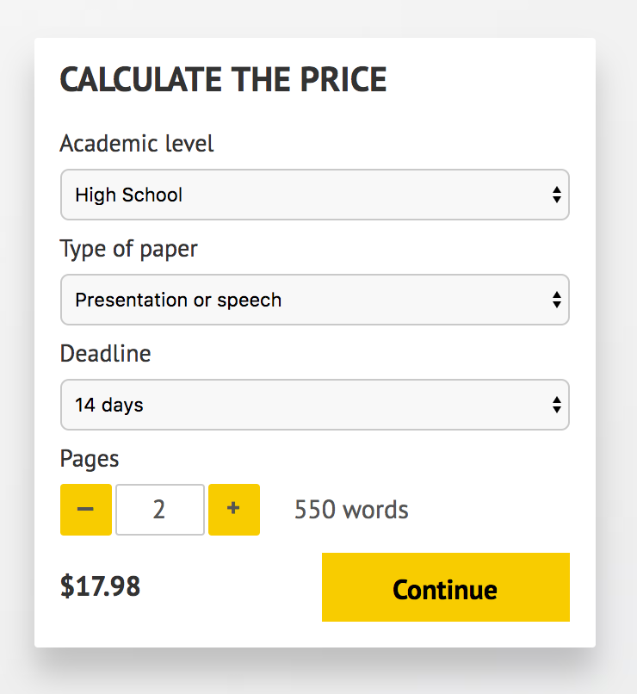](http://www.myspeechclass.com/go/custom-speech)

**IMPORTANT – PLEASE READ**

Don't use this speech as is! This document is available for anyone to download, and it has been used by *thousands* of people.

If you need help with writing a unique speech, please go to <http://www.myspeechclass.com/go/custom-speech> - you can order unique speech for as low as $17.98.