[Your Name]

[Instructor]

[Class]

[Date]

Why state aid applicants need to be drug tested

# Introduction

Every year, more and more states in the country require that state aid applicants undergo drug testing. And every time a new state implements this regulation, more and more people express disapproval over the law for different reasons. For sure, some of their ideas are valid and do make a lot of sense. But when seen in a positive light, drug testing state aid applicants can actually make this place a fairer place, both for honest taxpayers and legit welfare claimants.

# body

1. Drug testing state aid applicants do not bully the needy.

When a person in need is required to undergo a drug test before qualifying for a state aid, that person isn’t being picked on by the government because he or she is poor. Being drug tested doesn’t necessarily mean you are being suspected of illegal drug use. It means that the poor should not really feel like they’re being seen as more prone to use illegal drugs than other groups in society. It’s really just a basic process to complete a requirement. It’s actually no different than when applying for a job or for a driver’s license. If you have to be drug tested to get into a job, why not get drug tested to get some state aid?

1. State aid beneficiaries should reciprocate the free benefits they’re getting.

The government’s money comes from the taxpayers who have worked hard to earn their pay. So when anyone wants to take a portion of that money, the process shouldn’t be a one-way handout. Those who want to get something free from the government should at least do their part in assuring the state that the money they’re getting from the government are not wasted over drugs. So when the state requires welfare recipients to at least stop using illegal drugs if they do, people could see such a requirement as their main reciprocal obligation.

1. Drug testing state aid applicants will help make sure that government money is not wasted on self-destructive activities.

The fact that the poor are required to undergo a drug test before being accepted into the welfare program doesn’t mean they are considered to be more likely to use drugs than other groups in society. It only means that they are no different than other groups.

Drug use is so rampant that everyone, no matter where they stand in society, could be using drugs without being suspected. The poor should not be exempted from this simply because they are poor and are already vulnerable. The reason why they need to be drug tested is so that those who really need state aid would get the help they need while those who would only spend the money on drugs would be eliminated from the list. If a person would use drugs, he or she can’t make honest taxpayers to pay for his or her vice. Furthermore, those who truly need the aid will be identified and be given priority. When

# CONCLUSION

Drug testing welfare applicants shouldn’t be seen as a degrading process for the poor. In fact it is for them that this law has been made. When drug users are out of the picture, those who honestly need state aid would be identified. This way, we can all make sure that government money goes to those who really need it. After all, the government makes new laws year because we don’t live in a perfect world. If humanity were perfectly honest all the time, we wouldn’t even need a government. But because some people are actually prowling around like hungry lions, ready to take advantage of loopholes, we need to improve our laws to remain protected from abusers.

# WORKS CITED

Rector, R. (2011 December 15). *Welfare Programs Should Promote Self-sufficiency*. Retrieved from <http://www.usnews.com/debate-club/should-welfare-recipients-be-tested-for-drugs/welfare-programs-should-promote-self-sufficiency>

Williamson, J. (2014 January 2). *Florida Cannot Drug Test People Simply Because They’re Poor*. <https://www.aclu.org/blog/criminal-law-reform-racial-justice/florida-cannot-drug-test-people-simply-because-theyre-poor>

Bloom, R. (2011 October 12). *Poor People Have Rights Too*. <https://www.aclu.org/blog/criminal-law-reform-racial-justice/poor-people-have-rights-too>

[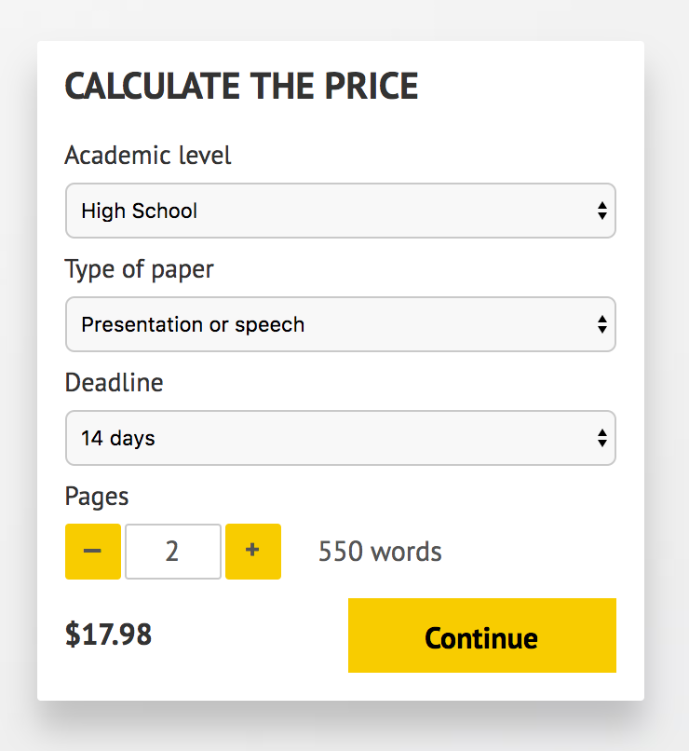](http://www.myspeechclass.com/go/custom-speech)

**IMPORTANT – PLEASE READ**

Don't use this speech as is! This document is available for anyone to download, and it has been used by *thousands* of people.

If you need help with writing a unique speech, please go to <http://www.myspeechclass.com/go/custom-speech> - you can order unique speech for as low as $17.98.