The Basics of Wind Energy

# INTRODUCTION

Everything that you do in your daily life requires energy. From the electricity used to power you alarm clock to the gas used in your car to heated water in your shower, you use a lot of energy to get through your typical day.

The energy that we use has to come from somewhere, and not all supplies of energy are sustainable or renewable.

In the United States, conserving energy and harnessing renewable sources of energy are increasingly important in discussions on energy. One source of renewable energy is wind energy, and today I’m going to tell you basics of wind energy, the advantages and disadvantages of wind energy, and the future of wind energy.

# BODY

1. Wind energy is among the oldest forms of renewable energy sources.

According to Liz Hartman of energy.gov, civilizations have harnessed the power of wind for thousands of years.

The earliest forms of wind energy can be seen in the way that sails were used to help boats move through the water. Wind energy was used by ancient Egyptians for sailing along the Nile according to a source from exploringgreentechnology.com.

A second form of wind energy is evident in the use of windmills. Using the power of wind energy, windmills were used to pump water or pulverize grain. Today, modern wind turbines are used to create electricity.

1. There are three ways that wind energy can be used for power.

First, wind energy can be used for sail power, which is possible when the force of wind is used to rotate rotor blades and allows a boat to move.

Second, wind energy can be used to create mechanical power. Mechanical power is a form of kinetic energy used to make parts move. For example, windmills are an example of mechanical energy. As wind blows on the panels of a windmill, the rotation creates a movement that can be used to move a stone as it crushes grain.

Finally, wind energy is used to turn mechanical power into electricity. An electrical wind turbine works much like a windmill, but instead of moving a stone, the wind turns a generator. A magnetic coil within the generator generates an electric current.

1. Wind energy has many advantages and few disadvantages, but is still a viable source of renewable energy.
2. Advantages of using wind energy.

Wind energy is an affordable form of energy. According to Hartman, in 2013 wind energy cost as little as 2.5 per kilowatt-hour, which is the lowest recorded price.

Wind energy is a renewable source of clean energy. Unlike oil or petroleum, the power of wind is created in nature by the uneven heating of the earth and it does not harm the environment with pollution.

Manufacturing the equipment used in producing wind turbines and other technologies provides over 50,000 jobs to people in the United States.

1. Disadvantages of using wind energy.

Wind energy is not a perfect form of energy. Wind is not always constant, so there can be some inconsistencies in the power that it produces.

Wind energy may also cause unintended consequences on the populations of certain animals like birds and bats.

Wind energy is not suitable for all locations.

1. Wind energy has a bright future in the world.

The use of wind energy is growing in the United States. Only China generates more wind energy than the United States.

The Department of Energy supports research for improving the use of wind energy. One initiative of the Energy Department is call Wind Vision which will support further research, development, and implementation of wind energy throughout the United States.

# CONCLUSION

Through this speech, I have informed you about the basics, advantages and disadvantages, and the future of wind energy. You can rest easy knowing that there are clean, renewable, and affordable ways to produce the energy that you need to get through your day.

# WORK CITIED

Hartman, L. (2014 August 18). Top 10 Things You Didn't Know about Wind Power Retrieved from http://energy.gov/articles/top-10-things-you-didnt-know-about-wind-power.

Wind Energy Facts. Retrieved February 15, 2015 from http://exploringgreentechnology.com/wind-energy/wind-energy-facts/.

[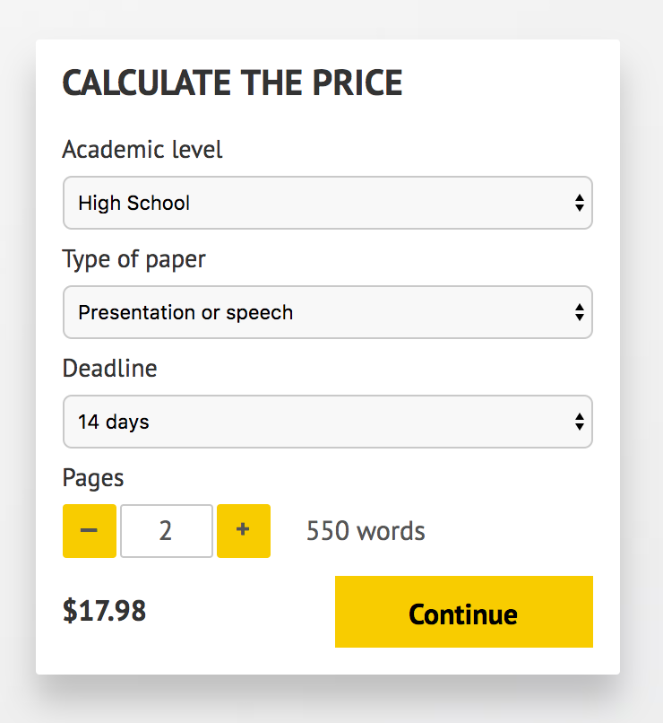](http://www.myspeechclass.com/go/custom-speech)

**IMPORTANT – PLEASE READ**

Don't use this speech as is! This document is available for anyone to download, and it has been used by *thousands* of people.

If you need help with writing a unique speech, please go to <http://www.myspeechclass.com/go/custom-speech> - you can order unique speech for as low as $17.98.