what to do about deadbeat parents?

# INTRODUCTION

In the United States today, a variety of socioeconomic factors have given rise to the infamous “deadbeat parent”, a parent who is unable or unwilling to meet his/her child support obligations. The current methods of combatting this social ill seem to be not only ineffective, but perhaps also play a part in creating the deadbeat parent.

The following are reasons for child support reform and some suggested reform options:

# BODY

1. Current child support policies have not decreased the percentage of children not receiving support.

Reginald Mombrun, citing Carole Chambers, writes that failing to pay child support is the largest single crime in America, and an estimated 75% to 87% of children receive no financial support from their non-custodial parent.

Such astronomical numbers indicate that, in spite of aggressive action by law enforcement against deadbeat parents, the deadbeat parent epidemic is not improving whatsoever.

1. Incarcerating deadbeat parents has a deleterious effect on the economy at large, and does nothing to help the children involved.

Ann Cammett, writing in the *Georgetown Journal on Poverty Law & Policy,* writes that incarceration serves only to remove an able adult from the job market, as well as limiting employment opportunities once they are released.

The simple reality is that an incarcerated parent is a parent that cannot work, and therefore cannot pay child support. Incarceration has a long-term negative impact on non-custodial parents, which adversely affects the children for whom the government has enacted these strict laws.

1. Current child support policies can be a barrier to highly beneficial involvement by non-custodial parents, both financial and non-financial.

Non-financial involvement by the non-custodial parent has a positive impact on the wellbeing of their children. “Children with involved nonresident fathers perform better academically” and “fewer social and behavioral problems” compared to children with uninvolved parents, according to Solangel Maldonado of Seton Hall University School of Law.

The aggressive prosecution of deadbeat parents may be contributing to the high level of poor, absent fathers. When such fathers do not have the means whereby to make child support payments, avoiding their children (and the mothers of those children) is more likely.

1. Instead of incarceration, employment programs tend to be more effective as means of ensuring child support is paid.

Per the federal Office of Child Support Enforcement, both voluntary and court ordered employment programs tend to increase the involvement of non-custodial parents in financial child support.

Several states are already running such programs, and the early results are showing promise. An added benefit from these programs is the subsequent decrease in the inmate population, which eliminates the high cost of incarceration.

As referenced by Seltzer and Meyer, studies show a positive association between paid child support and a child’s behavior, whereas incarceration potentially adds to behavioral issues. Depriving parents of the means to pay their child support helps no one.

1. Changing the method of determining income may also encourage regular child support payments.

Vicki Turetsky of the Office of Child Support Enforcement believes that “using an individual’s ‘real income’ vs. ‘computed income’ will encourage compliance.”

Unrealistic payment expectations only serve to guarantee that child support will not be paid, leading to debt for the parent and causing harm to the child’s wellbeing. Rather than blind bureaucratic dictums, perhaps case by case decisions would be in the best interest of the children and the non-custodial parents.

# CONCLUSION

The current child support system is very flawed, and is in some cases standing in the way of parents being able to provide for their children. It is incumbent upon society to open more paths for non-custodial parents to make their child support payments by eliminating harmful enforcement practices.

# WORKs CITED

Cammett, Ann (2011). Deadbeats, deadbrokes, and prisoners. *Scholarly Works.* Article 469. Retrieved from <http://scholars.law.unlv.edu/facpub/469>

Maldonado, Solangel (2006). Deadbeat or deadbroke: Redefining child support for fathers. *University of California, Davis.* Retrieved from [www.reentry.net/ny/library/attachment.105547](http://www.reentry.net/ny/library/attachment.105547)

Office of Child Support Enforcement. (2012). Promoting child well-being &family self-sufficiency. *Child Support Fact Sheet Series,* No. 11. Retrieved from <https://www.acf.hhs.gov/sites/default/files/ocse/improving_outcomes_through_employment_programs.pdf>

Seltzer, Judith A. & Meyer, Daniel R. (n.d.). Child support and children’s well-being. *Wisconsin Family Impact Seminars.* Retrieved from [www.researchgate.net/...**Child**_**Support_and_Children's**_**Well**-**Being**1/.../54](http://www.researchgate.net/...Child_Support_and_Children's_Well-Being1/.../54)...

Walters, Jonathan. (2013, July 16). Is jailing deadbeat dads effective? Retrieved from <http://www.governing.com/topics/health-human-services/col-jailing-deadbeat-dads-effective-child-support-payments.html>

[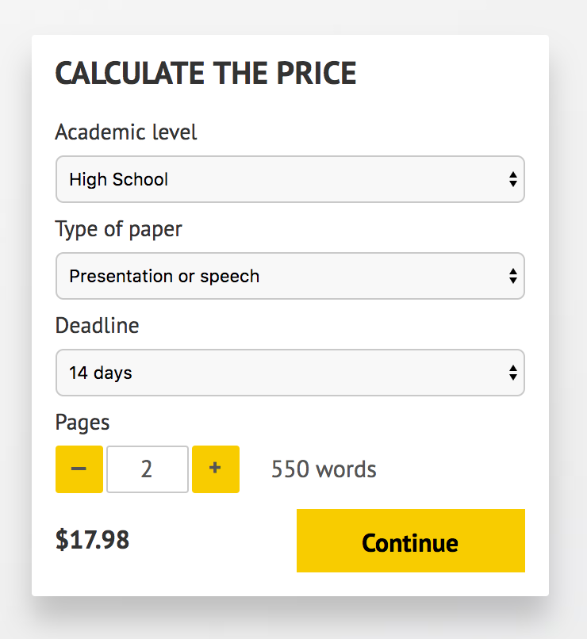](http://www.myspeechclass.com/go/custom-speech)

**IMPORTANT – PLEASE READ**

Don't use this speech as is! This document is available for anyone to download, and it has been used by *thousands* of people.

If you need help with writing a unique speech, please go to <http://www.myspeechclass.com/go/custom-speech> - you can order unique speech for as low as $17.98.